Bangladesh Medical Association (BMA)
List of Life Member-311
20. BMA Gazipur Branch

Sl No | Voter No | Voter Details
1 | Voter No  LM-2000001  No Image | DR. MD. ABDUL HALIM  F/Name:  M/Name:  BM & DC Reg. No:  NID:  Cell:  Address: Medical Officer, Kaliakor USC Kaliakair Gazipur  Blood Group:
2 | Voter No  LM-2000002  No Image | DR. HAYAT MAHMUD  F/Name:  M/Name:  BM & DC Reg. No:  NID:  Cell:  Address: Medical Officer, Sreepur Thana H.C Sreepur, Gazipur  Blood Group:
3 | Voter No  LM-2000003  No Image | DR. A. B. M. SAFIULLAH  F/Name:  M/Name:  BM & DC Reg. No: 21516  NID: 2697557397470  Cell: 01711186700  Address: 1/1-C (3rd Floor) Paribag, Dhaka-1000.  Blood Group: B+  TRANSFERED to BMA Dhaka City  LM-1405543
4 | Voter No  LM-2000004  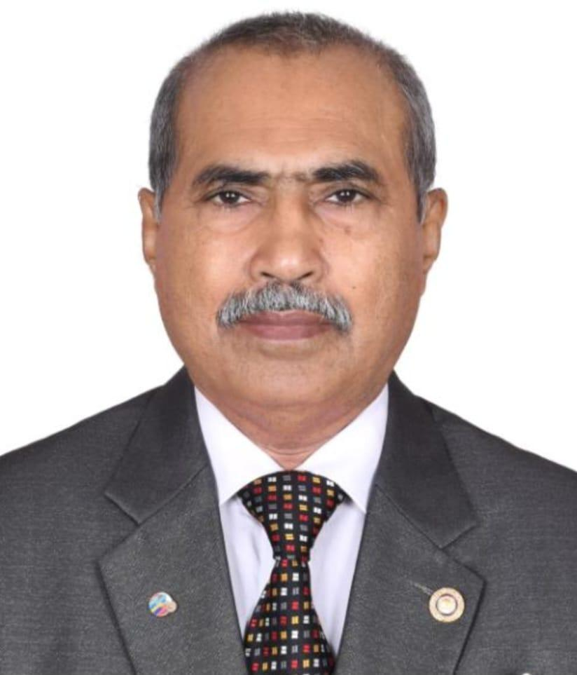 | DR. JALAL AHMED  F/Name: Abdul Barek Faraji  M/Name: Joynab Bibi  BM & DC Reg. No: 12228  NID: 1469224636  Cell: 01713017172  Address: Sheba Sushrasa Hospital, Tongi, Gazipur  Blood Group: O+
5 | Voter No  LM-2000005  No Image | DR. MD. ABUL KALAM  F/Name: Alhaz Md. Abdur Rahim Bhuiyan  M/Name:  BM & DC Reg. No:  NID:  Cell:  Address: Dr. Medi Care Station Road, Gazipur  Blood Group:
6 | Voter No  LM-2000006  No Image | DR. MOHAMMAD BADRUL HASAN  F/Name: Khorshed Ali Ahmed  M/Name:  BM & DC Reg. No:  NID:  Cell:  Address: MOIIT KB Bazar Gazipur  Blood Group:
7 | Voter No  LM-2000007  No Image | DR. NOOR MOHAMMAD ALI AZAM  F/Name: Abdun Noor Talukder  M/Name:  BM & DC Reg. No:  NID:  Cell:  Address: M.O. SPC Ltd. Gazipur  Blood Group:
8 | Voter No  LM-2000008  No Image | DR. MOHD. ABDUL MASUD  F/Name:  M/Name:  BM & DC Reg. No:  NID:  Cell:  Address: Sr. Consultant, Sador Hospital Gazipur  Blood Group:
9 | Voter No  LM-2000009  No Image | DR. MUHAMMAD SALMAN  F/Name: Muhammad Shuaib  M/Name:  BM & DC Reg. No: 12403  NID:  Cell:  Address: M.O, Kalaikor THC Kaliakair, Gazipur.  Blood Group:
10 | Voter No  LM-2000010  No Image | DR. NAZIM UDDIN AHMED  F/Name: Late Amzad Ali Sarker  M/Name:  BM & DC Reg. No:  NID:  Cell:  Address: 26/1 Anarkali Road Tongi, Gazipur  Blood Group:
11 | Voter No  LM-2000011  No Image | DR. MD. ANWAR HOSSAIN MUNSHI  F/Name: Late Ekram Hossain Munshi  M/Name:  BM & DC Reg. No:  NID:  Cell:  Address: TH & FPO, THC Kaliakair Gazipur  Blood Group:
12 | Voter No  LM-2000012  No Image | DR. ATM MOSTAFA KAMAL  F/Name: Md. Jabani Miah  M/Name:  BM & DC Reg. No:  NID:  Cell:  Address: Hasan Clinic , Natun Bazar, Tongi, Gazipur  Blood Group:
13 | Voter No  LM-2000013  No Image | DR. SALEH MOHAMMAD RAFIQ  F/Name: A. K. Shamsul Hoq  M/Name:  BM & DC Reg. No:  NID:  Cell:  Address: Modumita Road Tongi Gazipur  Blood Group:
14 | Voter No  LM-2000014  No Image | DR. MD. ABDUL KHALEQUE  F/Name: Late Md. Yeasin Meah  M/Name:  BM & DC Reg. No:  NID:  Cell:  Address: MO, THC Kaliakair, Gazipur.  Blood Group:
15 | Voter No  LM-2000015  No Image | DR. MD. HAFIZUR RAHMAN KHAN  F/Name: Late M. Musleem Uddin Khan  M/Name:  BM & DC Reg. No:  NID:  Cell:  Address: 17/1 South Chaya Bithi Joydevpur Gazipur  Blood Group:
16 | Voter No  LM-2000016  No Image | DR. SHAMSHED BEGUM  F/Name: Late Aziz Ahmed  M/Name:  BM & DC Reg. No:  NID:  Cell:  Address: M.O, Sador Hospital Gazipur  Blood Group:
17 | Voter No  LM-2000017  No Image | DR. DEWAN NAJIB AHSAN  F/Name: Md. Irshadullah  M/Name:  BM & DC Reg. No:  NID:  Cell:  Address: Sr. Consultant 50 Beded Hospital Tongi, Gazipur  Blood Group:
18 | Voter No  LM-2000018  No Image | DR. MD. ABDUR RAZZAQUE  F/Name:  M/Name:  BM & DC Reg. No:  NID:  Cell:  Address:  Blood Group:  TRANSFERED to BMA Dhaka City  LM-1405543
19 | Voter No  LM-2000019  No Image | DR. NEYAZ MUHAIMEN  F/Name: Muzammel Hoque  M/Name:  BM & DC Reg. No:  NID:  Cell:  Address: Sr. Consultant 50 Beded Hospital Gazipur  Blood Group:
20 | Voter No  LM-2000020  No Image | DR. SURAIYA YASMIN  F/Name:  M/Name:  BM & DC Reg. No:  NID:  Cell:  Address:  Blood Group:  TRANSFERED to BMA Dhaka City  LM-1405543
21 | Voter No  LM-2000021  No Image | DR. MD. SHAHJAHAN  F/Name: Md. Bajit Ali  M/Name:  BM & DC Reg. No:  NID:  Cell:  Address: Shilpy Medical Hall Sreepur Gazipur  Blood Group:
22 | Voter No  LM-2000022  No Image | DR. MD. MIZANUR RAHMAN KHAN  F/Name: Md. Jahir Uddin Khan  M/Name:  BM & DC Reg. No:  NID:  Cell:  Address: Islamia Pharmacy, T& T Gate Tongi Gazipur  Blood Group:
23 | Voter No  LM-2000023  No Image | DR. MOHAMMAD ANWAR HOSSAIN KHAN  F/Name: Md. Abdu Rashid  M/Name:  BM & DC Reg. No:  NID:  Cell:  Address: Kha - 1 , Drs Quarter Tongi Gazipur  Blood Group:
24 | Voter No  LM-2000024  No Image | DR. MD. MIZANUR RAHMAN  F/Name: Late Alhaj Abduttaher  M/Name:  BM & DC Reg. No:  NID:  Cell:  Address: 195, Borgo Moghbazar Gazipur  Blood Group:
25 | Voter No  LM-2000025  No Image | DR. MD. ABUL QUASHEM  F/Name: Md.Sujat Ali  M/Name:  BM & DC Reg. No:  NID:  Cell:  Address: Reg. MO, THC Kaliakair Gazipur  Blood Group:
26 | Voter No  LM-2000026  No Image | DR. KHAN MOHAMMAD SHARIF  F/Name: Md. Meser Ali Khan  M/Name:  BM & DC Reg. No:  NID:  Cell:  Address: Niramay, Kashimpur Road Konabari Gazipur  Blood Group:
27 | Voter No  LM-2000027  No Image | DR. ALHAJ MD. ENUUS ALI  F/Name: Alhaz Md. Nawab Ali  M/Name:  BM & DC Reg. No:  NID:  Cell:  Address: Srity Villa , Zorpukur Joydevpur Gazipur  Blood Group:
28 | Voter No  LM-2000028  No Image | DR. CHITTA RANJON DAS  F/Name:  M/Name:  BM & DC Reg. No:  NID:  Cell:  Address:  Blood Group:  TRANSFERED to BMA Dhaka City  LM-1405543
29 | Voter No  LM-2000028  No Image | DR. CHITTA RANJAN DAS  F/Name:  M/Name:  BM & DC Reg. No:  NID:  Cell:  Address: Medical Officer  Surgery Unit # 4, BSMMU,  Shahbagh, Dhaka.  Blood Group:  TRANSFERED to BMA Dhaka City  LM-1405543
30 | Voter No  LM-2000028  No Image | DR. CHITTA RANJON DAS  F/Name:  M/Name:  BM & DC Reg. No:  NID:  Cell:  Address: Medical Officer, Surgery Unit #4, BSMMU, Shahbagh,Dhaka  Blood Group:  TRANSFERED to BMA Dhaka City  LM-1405543
31 | Voter No  LM-2000029  No Image | DR. S M EJAJUL ISLAM  F/Name: Shah Easin  M/Name:  BM & DC Reg. No:  NID:  Cell:  Address: Chandona Med. Hall, Chaurasta Joydevpur Gazipur  Blood Group:
32 | Voter No  LM-2000030  No Image | DR. MUHAMMAD SHEFAUL HUQ  F/Name: Md. Abbul Huq  M/Name:  BM & DC Reg. No:  NID:  Cell:  Address: Sador Hospital Gazipur  Blood Group:
33 | Voter No  LM-2000031  No Image | DR. MD. ABDUL KADER  F/Name: Alhaj Md. Jamal Uddin  M/Name:  BM & DC Reg. No:  NID:  Cell:  Address: Gazipur Med. Cetnre, Rajbari Rd Gazipur  Blood Group:
34 | Voter No  LM-2000032  No Image | DR. S. M. NIZAMUL HUQ  F/Name: Late S. M. Ezahar Uddin  M/Name:  BM & DC Reg. No:  NID:  Cell:  Address: Asst. Director, DFPO Gazipur  Blood Group:
35 | Voter No  LM-2000033  No Image | DR. TOUHIDA AHSAN  F/Name: Late Prinicipal Abul Kashem  M/Name:  BM & DC Reg. No:  NID:  Cell:  Address: 48, Station Road Joydevpur Gazipur  Blood Group:
36 | Voter No  LM-2000034  No Image | DR. MD. ABDUL MUTTALIB  F/Name: Md. Mofiz Uddin Sarker  M/Name:  BM & DC Reg. No:  NID:  Cell:  Address: RMO, Sreepur, Gazipur  Blood Group:
37 | Voter No  LM-2000035  No Image | DR. AFM NOWSHER ALI  F/Name:  M/Name:  BM & DC Reg. No:  NID:  Cell:  Address: TRANSFERED To BMA Sirajgonj Br., LM-6200028  Blood Group:  TRANSFERED to BMA Dhaka City  LM-1405543
38 | Voter No  LM-2000036  No Image | DR. NISHI RANJAN SHAHA  F/Name: Late Ganesh C. Shaha  M/Name:  BM & DC Reg. No:  NID:  Cell:  Address: Civil Surgon, Gazipur Gazipur  Blood Group:
39 | Voter No  LM-2000037  No Image | DR. MD. FORHAD HOSSAIN  F/Name: Alhaj Md. Ibrahim Khalil Ullah  M/Name:  BM & DC Reg. No:  NID:  Cell:  Address: Consultant Eye Sador Hospital Gazipur  Blood Group:
40 | Voter No  LM-2000038  No Image | DR. AMANUL KABIR BOLTA  F/Name:  M/Name:  BM & DC Reg. No:  NID:  Cell:  Address:  Blood Group:  TRANSFERED to BMA Dhaka City  LM-1405543
41 | Voter No  LM-2000039  No Image | DR. NURUN NAHAR BEGUM  F/Name: Md. Sujat Ali Sarker  M/Name:  BM & DC Reg. No:  NID:  Cell:  Address: 44/9, Khilgaon, Block - A Dhaka  Blood Group:
42 | Voter No  LM-2000040 | DR. MD. SHAFIUR RAHMAN  F/Name: Tezarat Ali Biswas  M/Name: Fatema Khatun  BM & DC Reg. No: 26768  NID: 8217380442621  Cell: 01717655493  Address: H#41 (3rd Floor) R#3/F, S#9, Uttara, Dhaka.  Blood Group: O+
43 | Voter No  LM-2000040  No Image | DR. MD. SHAFIUR RAHMAN  F/Name: Md. Tofazzal Hossain  M/Name:  BM & DC Reg. No:  NID:  Cell:  Address:  Blood Group:
44 | Voter No  LM-2000041  No Image | DR. SAMIRAN KUMAR KUNDU  F/Name: Ram Chandra Kundu  M/Name:  BM & DC Reg. No:  NID:  Cell:  Address: 74, West Testuri Bazar Tejgaon Dhaka  Blood Group:
45 | Voter No  LM-2000042  No Image | DR. ROKEYA BEGUM  F/Name: Late S. M. Yusuf  M/Name:  BM & DC Reg. No:  NID:  Cell:  Address: Medical Officer 50 Beded Hospital Gazipur  Blood Group:
46 | Voter No  LM-2000043  No Image | DR. MD. ABDUL BASET  F/Name: Khalilur Rahman  M/Name:  BM & DC Reg. No:  NID:  Cell:  Address:  Blood Group:
47 | Voter No  LM-2000044  No Image | DR. IFTEKEHAR AHMED  F/Name: Abdur Rahim  M/Name:  BM & DC Reg. No:  NID:  Cell:  Address: Medical Officer 50 Beded Hospital Gazipur  Blood Group:
48 | Voter No  LM-2000045  No Image | DR. AHM MONZURUL HAQUE  F/Name: Azizur Rahman  M/Name:  BM & DC Reg. No:  NID:  Cell:  Address:  Blood Group:
49 | Voter No  LM-2000046  No Image | DR. TAHIRA SALWA JABBER  F/Name: Late Abdul Jabber  M/Name:  BM & DC Reg. No:  NID:  Cell:  Address: M.O. FWC, Mirjapur Gazipur.  Blood Group:
50 | Voter No  LM-2000047  No Image | DR. SHARIF MOHAMMAD ISMAIL HOSSAIN  F/Name: Mainuddin Miah  M/Name:  BM & DC Reg. No:  NID:  Cell:  Address: Badakal, Mesher KB Bazar Gazipur  Blood Group:
51 | Voter No  LM-2000048  No Image | DR. MD. AMIR HOSSAIN RAHAT  F/Name: Md. Ala Uddin  M/Name:  BM & DC Reg. No:  NID:  Cell:  Address: Alpha Medical Lab Rajbari Road (2nd Floor) Gazipur-1700.  Blood Group:
52 | Voter No  LM-2000049  No Image | DR. MD. ISMAIL HOSSAIN SIRAJEE  F/Name: Md. Idris Miah  M/Name:  BM & DC Reg. No:  NID:  Cell:  Address: M.O Sador Hospital Gazipur  Blood Group:
53 | Voter No  LM-2000050  No Image | DR. MD. MAJIBUR RAHMAN  F/Name: Late Mvi Mohammad Ali  M/Name:  BM & DC Reg. No:  NID:  Cell:  Address: M.O Sador Hospital Gazipur  Blood Group:
54 | Voter No  LM-2000051  No Image | DR. MD. DELWAR HOSSAIN  F/Name: Abdul Ghani  M/Name:  BM & DC Reg. No:  NID:  Cell:  Address: Chowd. Oushad Biponi, Hosain Mark. Tongi Gazipur  Blood Group:
55 | Voter No  LM-2000052  No Image | DR. SUKDEB PAUL  F/Name: Sree Sukumar Paul  M/Name:  BM & DC Reg. No:  NID:  Cell:  Address: Barmi Bazar, Barmi Sreepur Gazipur  Blood Group:
56 | Voter No  LM-2000053 | DR. KAZI SHAHADAT HOSSAIN  F/Name:  M/Name:  BM & DC Reg. No:  NID:  Cell:  Address: TH & FPO, THC Kaligonj Gazipur  Blood Group:
57 | Voter No  LM-2000054  No Image | DR. REZAUL HAQUE  F/Name:  M/Name:  BM & DC Reg. No:  NID:  Cell:  Address:  Blood Group:
58 | Voter No  LM-2000055  No Image | DR. RATI ROMANA BINTA RAHMAN  F/Name:  M/Name:  BM & DC Reg. No:  NID:  Cell:  Address: Sr. Consultant Tongi Gazipur  Blood Group:
59 | Voter No  LM-2000056  No Image | DR. KAZI MD. HASSAN AMIN  F/Name: Kazi Mohammad Moslem Uddin  M/Name:  BM & DC Reg. No:  NID:  Cell:  Address: Seba Medical Centre Tongi, Gazipur  Blood Group:
60 | Voter No  LM-2000057  No Image | DR. SHAMSUN NAHAR  F/Name: Shamsul Haque  M/Name:  BM & DC Reg. No:  NID:  Cell:  Address: Sr. Consultant 50 Beded Hospital Gazipur  Blood Group:
61 | Voter No  LM-2000058  No Image | DR. MD. ABDUL KADER  F/Name: A. K. M. Asmat Ali  M/Name:  BM & DC Reg. No:  NID:  Cell:  Address: Anar Kutir Joydevpur Bus Stand Gazipur  Blood Group:
62 | Voter No  LM-2000059  No Image | DR. SABBIR AHMED KHAN  F/Name: Late Mohiuddin  M/Name:  BM & DC Reg. No:  NID:  Cell:  Address: Consultant Surgon Sador Hospital Gazipur  Blood Group:
63 | Voter No  LM-2000060  No Image | DR. MD. ABDUR RAZZAQUE  F/Name: Md. Abdur Rahim Sarker  M/Name:  BM & DC Reg. No:  NID:  Cell:  Address: TH & FPO., Horirampur,  Manikgonj.  Blood Group:
64 | Voter No  LM-2000061  No Image | DR. MD. NAZMUL HUDA  F/Name:  M/Name:  BM & DC Reg. No:  NID:  Cell:  Address: onsultant E.N.T Sadar Hospital, Gazipur.  Blood Group:
65 | Voter No  LM-2000062  No Image | DR. MD. ABU ELIAS PRODHAN  F/Name:  M/Name:  BM & DC Reg. No:  NID:  Cell:  Address: UHC., Kaliakoir,Gazipur  Blood Group:  TRANSFERED to BMA Dhaka City  LM-1405543
66 | Voter No  LM-2000062  No Image | DR. MD. ABU ELIAS PRODHAN  F/Name:  M/Name:  BM & DC Reg. No: 9207  NID:  Cell:  Address:  Blood Group: A+  TRANSFERED to BMA Dhaka City  LM-1405543
67 | Voter No  LM-2000063 | DR. MD. HUMAYUN KABIR KHAN  F/Name: Late Mahfuzur Rahman Khan  M/Name:  BM & DC Reg. No: 20381  NID:  Cell:  Address: Al Hera Medical Center, Bogra.  Blood Group:
68 | Voter No  LM-2000064  No Image | DR. MD. ASHRAF UDDIN  F/Name: Md. Idris Ali  M/Name:  BM & DC Reg. No:  NID:  Cell:  Address: H-14, R- 37 S-9, Uttara Dhaka  Blood Group:
69 | Voter No  LM-2000065  No Image | DR. JAMAL HOSSAIN  F/Name: Hosen Ali Khan  M/Name:  BM & DC Reg. No:  NID:  Cell:  Address: 182/2 Zorpurkurpar Joydevpur Gazipur  Blood Group:
70 | Voter No  LM-2000066  No Image | DR. A. B. M. MUSA  F/Name: Late Md. Abul Aziz  M/Name:  BM & DC Reg. No:  NID:  Cell:  Address: Seba Drug, Tangail Road, Chandona, Gazipur.  Blood Group:
71 | Voter No  LM-2000067 | DR. MD. ISMAIL HOSSAIN  F/Name: Md. Meshba Uddin  M/Name:  BM & DC Reg. No:  NID:  Cell:  Address: House No- Usha 3 Joydevpur Gazipu  Blood Group:
72 | Voter No  LM-2000068  No Image | DR. RASIDA BEGUM  F/Name: Late Md. Azhar Ali  M/Name:  BM & DC Reg. No:  NID:  Cell:  Address: House No- Usha 3 Joydevpur Gazipur  Blood Group:
73 | Voter No  LM-2000069  No Image | DR. MOHAMMAD KHALILUR RAHMAN  F/Name: Late Moksed Ali  M/Name:  BM & DC Reg. No:  NID:  Cell:  Address: Bhora, Joydevpur Gazipur  Blood Group:
74 | Voter No  LM-2000070  No Image | DR. SHAHANA NAZNEEN  F/Name: Shah Kamal  M/Name:  BM & DC Reg. No:  NID:  Cell:  Address: Kha -3, Doctors Quarter Sador Hospital Gazipur  Blood Group:
75 | Voter No  LM-2000071  No Image | DR. MD. ABDUL HAMID  F/Name: Late Md. Hasen Uddin  M/Name:  BM & DC Reg. No:  NID:  Cell:  Address: Shamsul Medical Hall, Raibari Road Gazipur  Blood Group:
76 | Voter No  LM-2000072  No Image | DR. MD. ANISUZZAMAN  F/Name: Md. Masudur Rahman  M/Name:  BM & DC Reg. No:  NID:  Cell:  Address: Kha -3, Doctors Quarter Sador Hospital Gazipur  Blood Group:
77 | Voter No  LM-2000073  No Image | DR. HABIBUL HAI MASUD  F/Name: Fakir Abdul Hai  M/Name:  BM & DC Reg. No:  NID:  Cell:  Address: Consultant Anaesthesia Sador Hospital Gazipur  Blood Group:
78 | Voter No  LM-2000074  No Image | DR. SOHEL AHMED KHAN  F/Name: Md. Motiur Rahman Khan  M/Name:  BM & DC Reg. No:  NID:  Cell:  Address: H -87, R- 18, Sector - 7 Uttara Dhaka  Blood Group:
79 | Voter No  LM-2000075  No Image | DR. HUSNE ARA BEGUM  F/Name: Alhaj Ali Akbar  M/Name:  BM & DC Reg. No:  NID:  Cell:  Address: Asst. Prof., Community Medicine Nipsom Dhaka  Blood Group:
80 | Voter No  LM-2000076  No Image | DR. MD. SHAMSUL HAQUE  F/Name: Late Md. Sirajul Islam  M/Name:  BM & DC Reg. No:  NID:  Cell:  Address: RMO, UHC, Srepur, Gazipur Gazipur  Blood Group:
81 | Voter No  LM-2000077  No Image | DR. WADIA BEGUM  F/Name: Md. Ziaur Rahman  M/Name:  BM & DC Reg. No:  NID:  Cell:  Address: Doctors Quarter Kha -150 Beded Hospital Gazipur  Blood Group:
82 | Voter No  LM-2000078  No Image | DR. SHAHEEN SHARIAR  F/Name: Late Md. Sirajul Islam  M/Name:  BM & DC Reg. No:  NID:  Cell:  Address: Zaman Drugs Rajbari Road Gazipur  Blood Group:
83 | Voter No  LM-2000079  No Image | DR. A.K.M KHALEQUZZAMAN DIPU  F/Name: A. K. M. Abdun Naim  M/Name:  BM & DC Reg. No:  NID:  Cell:  Address: 616- H, Block - A BSMMU, Shahbag Dhaka  Blood Group:
84 | Voter No  LM-2000080  No Image | DR. NURUNNAHAR BEGUM  F/Name: Late Jala Uddin  M/Name:  BM & DC Reg. No:  NID:  Cell:  Address: Gazipur Sador Upzila Gazipur  Blood Group:
85 | Voter No  LM-2000081  No Image | DR. MD. AZIZUL ISLAM  F/Name: Late Jashim Uddin  M/Name:  BM & DC Reg. No:  NID:  Cell:  Address: Ratonpur Kaliakair Gazipur  Blood Group:
86 | Voter No  LM-2000082  No Image | DR. MD. ABDUR RAHSID  F/Name:  M/Name:  BM & DC Reg. No:  NID:  Cell:  Address:  Blood Group:  TRANSFERED to BMA Dhaka City  LM-1405543
87 | Voter No  LM-2000083  No Image | DR. ROMA AKTER  F/Name: Muhammad Adbul Aziz  M/Name:  BM & DC Reg. No:  NID:  Cell:  Address: Shafipur Thana, Kaliakair, Gazipur  Blood Group:
88 | Voter No  LM-2000084  No Image | DR. MD. KAMRUL HASAN  F/Name: Md. Majebar Rahman  M/Name:  BM & DC Reg. No:  NID:  Cell:  Address: Shafipur General Hospital Kaliakair Gazipur  Blood Group:
89 | Voter No  LM-2000085  No Image | DR. MOHAMMAD AFZALUL BASHAR  F/Name: Mohammad Alauddin  M/Name:  BM & DC Reg. No:  NID:  Cell:  Address: Shafipur General Hospital Kaliakair Gazipur  Blood Group:
90 | Voter No  LM-2000086  No Image | DR. MONIRA AKHTER  F/Name: Md. Mofiz Uddin  M/Name:  BM & DC Reg. No:  NID:  Cell:  Address: F- 123, Uttar Sayabithi Joydevpur Gazipur  Blood Group:
91 | Voter No  LM-2000087 | DR. MOHAMMAD KAMRUL ISLAM  F/Name: Late Md. Khelu Miah  M/Name: Mrs. Fatema Begum  BM & DC Reg. No: 32255  NID:  Cell: 01711706773  Address: 119/1, Dhirasrom Road, Parba Chandona, Joydebapur, Gazipur  Blood Group: AB_po
92 | Voter No  LM-2000088 | DR. MOHAMMAD KHAIRUZZAMAN  F/Name: Sheikh Golam Mostafa  M/Name: Khodeza Begum  BM & DC Reg. No: 38129  NID:  Cell: 01712659878  Address: House no: GPS-59, Vill: East Chandona (Laksmipura) P.O: Gazipur-1700, P.s: Jaydebpur(Gazipur Sadar), Dist: Gazipur  Blood Group: B+
93 | Voter No  LM-2000089 | DR. NASEEM BEGAM  F/Name: Sk. Shamsuddin Ahmed  M/Name: Mrs. Dollanara Begum  BM & DC Reg. No: 25909  NID: 2699501907937  Cell: 01731914505  Address: House#87(4/B): Road #18, Sector-07, Uttara, Dhaka  Blood Group: B+
94 | Voter No  LM-2000090 | DR. SURMYA SULTANA  F/Name: Late Hafizur Rahman  M/Name: Late Hamida Begum  BM & DC Reg. No: 14402  NID: 2619551197852  Cell: 01715079093  Address: House-31, Road-21, Sector-14, Uttara Model Towar, Dhaka  Blood Group: O+
95 | Voter No  LM-2000091 | DR. MD. JAHANGIR HOSSAIN  F/Name: Al-Hajj Md. Kamal Uddin  M/Name: Mrs. Hamida Banu  BM & DC Reg. No: 14401  NID: 2619551171455  Cell: 01711545270  Address: House-31, Road-21, Sector-14, Uttax Model Town, Dhaka-1230  Blood Group: O+
96 | Voter No  LM-2000092 | DR. JOBEDA KHATUN  F/Name: Hazi Mehar Uddin  M/Name: Mrs. Mazeda Khatun  BM & DC Reg. No: 30339  NID: 3313238937897  Cell: 01727014929  Address: Shafipur General Hospital Kaliakoir Gazipur  Blood Group:
97 | Voter No  LM-2000093  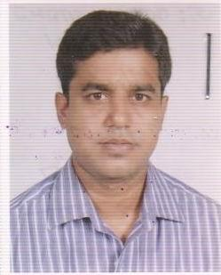 | DR. MOHAMMAD KAMRUL ISLAM  F/Name: Late Md. Khelu Miah  M/Name:  BM & DC Reg. No:  NID:  Cell:  Address: 119/1, Dhirasram Rd, Purba Chandona, Joydebpur, Gazipur  Blood Group: n_a
98 | Voter No  LM-2000094  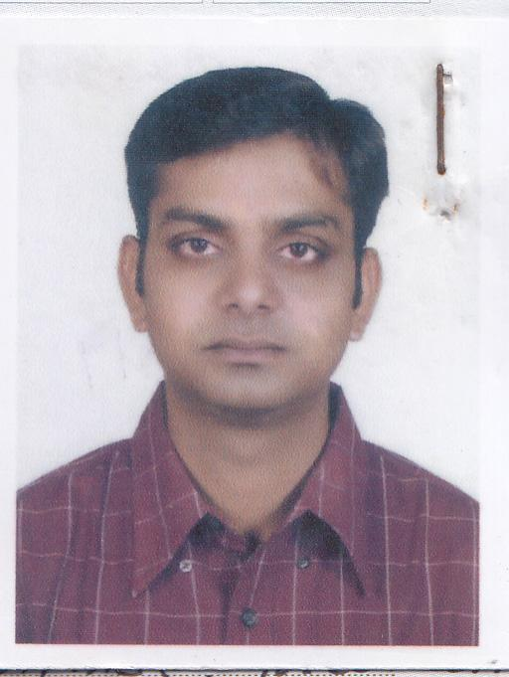 | DR. MOHAMMAD KHAIRUZZAMAN  F/Name: Sheikh Golam Mostofa  M/Name: Khodeza Begum  BM & DC Reg. No: 38129  NID:  Cell:  Address: House-GPS-59, Vill East Chandona (Laksmipura), Po: Gazipur-1700, Ps: Joydepur (Gazipur Sadar), Dist: Gazipur.  Blood Group: B+
99 | Voter No  LM-2000095  No Image | DR. NASEEM BEGUM  F/Name: Sk Shamsuddin Ahmed  M/Name:  BM & DC Reg. No:  NID:  Cell:  Address: House No 87/4/B, Rd 18, Sector 7, Uttara, Dhaka-1230  Blood Group:
100 | Voter No  LM-2000096  No Image | DR. SURAIYA SULTANA  F/Name: Late Hafizur Rahman  M/Name:  BM & DC Reg. No:  NID:  Cell:  Address: House No 31, Rd No 21, Sector-14, Uttara Model Town, Dhaka  Blood Group:
101 | Voter No  LM-2000097  No Image | DR. MD.JAHANGIR HOSSAIN  F/Name: Alhaj Md. Kamal Uddin  M/Name:  BM & DC Reg. No:  NID:  Cell:  Address: House No-31, Rd No 21, Sector 14, Uttara Model Town, Dhaka-1230  Blood Group:
102 | Voter No  LM-2000098  No Image | DR. JOBEDA KHATUN  F/Name: Hazi Mehar Uddin  M/Name:  BM & DC Reg. No:  NID:  Cell:  Address: Shafipur General Hospital, Kaliakoir, Gazipur.  Blood Group:
103 | Voter No  LM-2000099  No Image | DR. NAZMA AKHTER  F/Name: Md. Shamsul Haque  M/Name:  BM & DC Reg. No:  NID:  Cell:  Address: D-3, Mogina, Bof, Gazipur Cant, Gazipur.  Blood Group:
104 | Voter No  LM-2000100  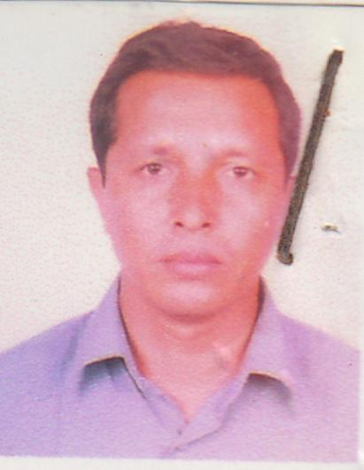 | DR. MD. GOLAM MUSTAFA MAJUMDER  F/Name: Md. Serajul Huq Majumder  M/Name: Asmater Nessa  BM & DC Reg. No: 18010  NID: 2699040725341  Cell: 01726245793  Address: Doctor’s Quarter, Upazila Health Comple Kaligonj, Gazipur.  Blood Group: O+
105 | Voter No  LM-2000101  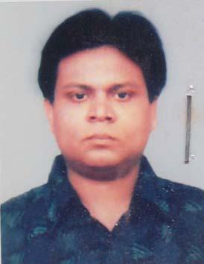 | DR. RAJAT SHUVRA PAUL  F/Name: Yauranga Chandra Paul  M/Name: Kalabathi Paul  BM & DC Reg. No: 32161  NID: 3323003121474  Cell: 01711680896  Address: Joydebpur Bazar, Gazipur-1700  Blood Group: B+
106 | Voter No  LM-2000102  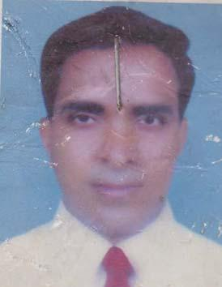 | DR. LUTFOR RAHMAN MOLLA  F/Name: Md. Abdul Wahab Molla  M/Name: Mrs. Gulnahar Begum  BM & DC Reg. No: 33480  NID: 19763323021000009  Cell: 01817524734  Address: Vill- Dattapara, P.O- Ershadnagar, P.S- Tongi, Dist- Gazipur  Blood Group: B+
107 | Voter No  LM-2000103  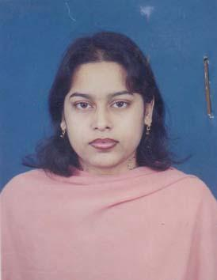 | DR. NUSTAT ZAHAN  F/Name: Prof. Nurul Islam  M/Name: Rabeya Islam  BM & DC Reg. No: 52097  NID: 61122111808  Cell: 01711467835  Address: Shabipu General Hospital Kaliakoir, Gazipur  Blood Group: B+
108 | Voter No  LM-2000104  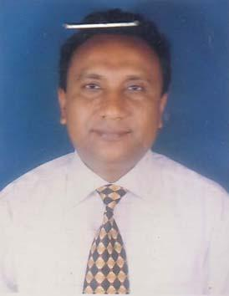 | DR. MD. SHAFIQUL ISLAM  F/Name: Late Md. Abdul Kadir Akond  M/Name: Mrs. Soboron Nesa  BM & DC Reg. No: 20701  NID:  Cell: 01713454222  Address: Vill- Ghilar-Chala, P.0- Ghila Beraid, P.s- Sreepur, Dist- Gazipur  Blood Group: B+
109 | Voter No  LM-2000105 | DR. HARADHON DAS  F/Name: Joy Chandra Das  M/Name: Maloti Rani Das  BM & DC Reg. No: 41642  NID: 3323003120710  Cell: 01817103541  Address: H# H-359, Thana-Road, Joydebpur-Bazar, Gazipur- Sadar, Gazipur-1700, Gazipur  Blood Group: A+
110 | Voter No  LM-2000106  No Image | DR. JANNAT ARA RUMANA  F/Name: Md. Jamir Uddin  M/Name: Rashida Banu  BM & DC Reg. No: 43902  NID: 2696830027279  Cell: 01710656246  Address: D/109, Joydebpur, Purba-Madhya, Joydebpur, Gazipur Sadar, Gazipur  Blood Group: A+
111 | Voter No  LM-2000107  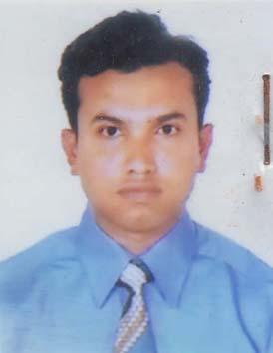 | DR. MOHAMMAD SALIM  F/Name: Mohammad Asmat Ali Mozumder  M/Name: Mazeda Khatun  BM & DC Reg. No: 44253  NID: 19823323004134954  Cell: 01720049976  Address: D/109, Joydebpur PJRBA Madhya, Joydebpur, Gazipur Sadar, Gazipur  Blood Group: B+
112 | Voter No  LM-2000108  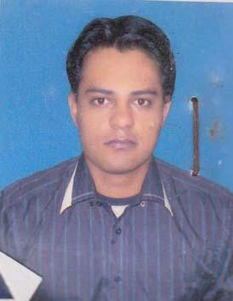 | DR. KHONDADER ABUL BASHAR  F/Name: Khondaker Golam Mostafa  M/Name: Mrs. Salma Khatun  BM & DC Reg. No: 51613  NID:  Cell: 01717385925  Address: Bangladesh Ordinance Factory, Rcs-D/E-4/5, Shimultuli, Gazipur  Blood Group: B+
113 | Voter No  LM-2000109 | DR. MD. KAISAR SIKDER  F/Name: Late Sanaullah Sikder  M/Name: Bilkis Akhter  BM & DC Reg. No: 52496  NID: 3313067993357  Cell: 01716428045  Address: House no: 273/2 Block-A, West Joydebpur, Gazipur Sadar, Gazipur  Blood Group: AB_po
114 | Voter No  LM-2000110 | DR. SHARMINA HAQUE  F/Name: Shamsul Hoque  M/Name: Morium Begum  BM & DC Reg. No: 46158  NID:  Cell: 01712826694  Address: 35/10/I Road-2, Shamoli, Dhaka  Blood Group: A+
115 | Voter No  LM-2000111  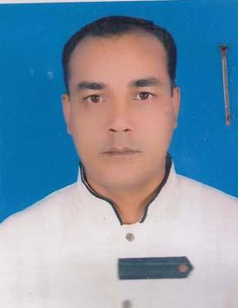 | DR. S.M. OMAR FARUK  F/Name: Late. Md. Elias Hossen  M/Name: Most. Aziza Begum  BM & DC Reg. No: 33669  NID: 8514923341243  Cell: 01819660633  Address: Baroboika : Chandona Churasta, Gazipur  Blood Group: O+
116 | Voter No  LM-2000112 | DR. MD. SOHRAB HOSSAIN  F/Name: Md. Mukbul Hossain  M/Name: Begum Samsunnahar  BM & DC Reg. No: 45835  NID:  Cell: 01716973002  Address: Nandail Upazilla Health Complex, Mymensingh  Blood Group: A+
117 | Voter No  LM-2000113  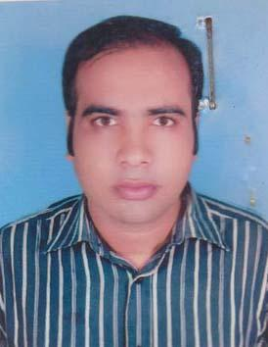 | DR. MOHAMMAD MIZANUR RAHMAN  F/Name: Mohammad Shafiullah  M/Name: Mukseda Khatun  BM & DC Reg. No: 46049  NID: 3313031807111  Cell: 01711026016  Address: Vill: Kamarjury, P.O: Gacha (Gazipur-1704) Gazipur Sadar, Gazipur  Blood Group: AB_po
118 | Voter No  LM-2000114  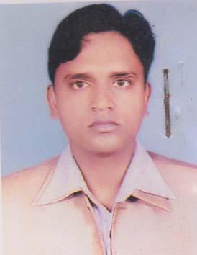 | DR. MOHAMMAD KHALED IQBAL  F/Name: Mohammad Yousuf Miah  M/Name: Sufia Begum  BM & DC Reg. No: 45052  NID:  Cell: 01913165388  Address: Vill- Ichhar, P.O -Gacha, P.s- Sadar, Dist- Gazipur  Blood Group: A+
119 | Voter No  LM-2000115 | MD. SHARIF HOSSAIN  F/Name: Md. Gias Uddin  M/Name: Mrs. Mazeda Khatoon  BM & DC Reg. No: 46144  NID:  Cell: 01712570950  Address: K-9/15 Poschim Bilashpur, Joydebpur, Gazipur  Blood Group: O+
120 | Voter No  LM-2000116  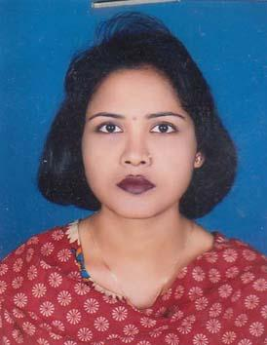 | DR. TASLIMA AKHTER  F/Name: Mohammed Hasen Ali  M/Name: Ramija Khaton  BM & DC Reg. No: 37393  NID: 19773323005146249  Cell: 01733696366  Address: Vill- Noyagonj, P.O- Gazipur Sadar, P.S- Gazipur Sadar, Dist- Gazipur  Blood Group: O+
121 | Voter No  LM-2000117 | DR. MD. MANOWARUL ISLAM  F/Name: Md. Mozaharul Islam  M/Name: Mrs. Manowara Begum  BM & DC Reg. No: 30163  NID:  Cell: 01819257940  Address: 12/D. Anando Dip Housing Complex, Chandora Chowrasta, Gazipur  Blood Group: B+
122 | Voter No  LM-2000118  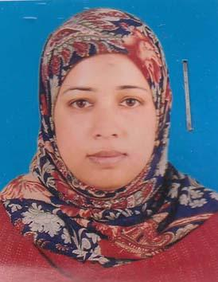 | DR. ASMA BEGUM  F/Name: Kazi Siddiqur Rahman  M/Name: Mr. Sabrina Begum  BM & DC Reg. No: 42727  NID: 2699501913707  Cell: 01715315733  Address: South Shattar, B.O.F. Gazipur Sadar, Gazipur  Blood Group: O+
123 | Voter No  LM-2000119  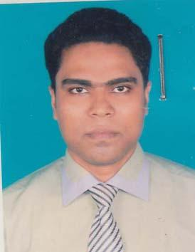 | DR. MD. MAZHARUL ALAM  F/Name: Md. Gyas Uddin  M/Name: Khodega Begum  BM & DC Reg. No: 40676  NID: 6112211111782  Cell: 01717559319  Address: Shabipur General Hospital Kaliakoir, Gajipur  Blood Group: O+
124 | Voter No  LM-2000120  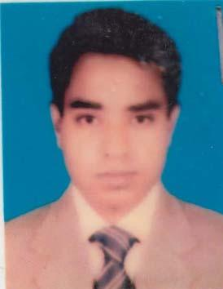 | DR. MD. TARIQUL ISLAM  F/Name: Alhaj Md. Mowla Baksh  M/Name: Alhaj Mrs. Tahmina Begum  BM & DC Reg. No: 37377  NID: 3313031004869  Cell: 01711247018  Address: \'Tahmina Monjil, Badsha Mia School Road, Boordbazar, Joydebpur, Gazipur  Blood Group: O+
125 | Voter No  LM-2000121  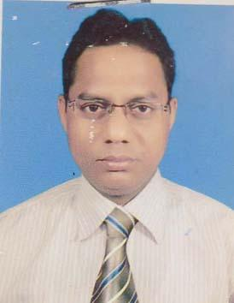 | DR. MOHAMMAD ANAMUL HAQUE  F/Name: Late Md. Amir Uddin Dorjee  M/Name: Mrs. Badrun Nesa  BM & DC Reg. No: 36215  NID: 3313054986806  Cell: 01711902098  Address: C/O Md Hasen Ali, House No- 115, (GPS) Noagaon, Joydebpur, Gazipur  Blood Group: O+
126 | Voter No  LM-2000122  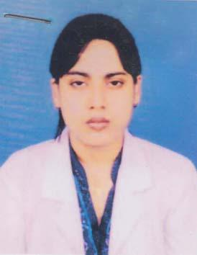 | DR. EFFAT ZAHAN ABDULLAH  F/Name: Late Abdullah  M/Name: Mrs. Samsun Naher Begum  BM & DC Reg. No: 45929  NID: 852490402877  Cell: 01717052537  Address: Bahubal UHC, Hobiganj  Blood Group: A+
127 | Voter No  LM-2000123  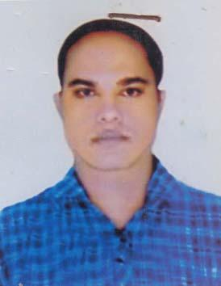 | DR. MD. MANIRUZZAMAN  F/Name: Late Alhaj Md. Siddiqur Rahman  M/Name: Rezia Begum  BM & DC Reg. No: 27379  NID: 3323001105642  Cell: 01711054213  Address: 332, West Vurulia (Fakir Bari) P.O- Duet, Gozipur, P.S- Joydebpur, Gazipur  Blood Group: AB_po
128 | Voter No  LM-2000124 | DR. MOHAMMAD IBRAHIM KHALIL  F/Name: Md. Arab Uddin Sharker  M/Name: Rahima Khatun  BM & DC Reg. No: 27224  NID:  Cell: 01819284353  Address: 12/C Ananda Dip Housing Complex, P.O- Chandana, Ps- Joydebpur, Dist- Gazipur-1702  Blood Group: AB_po
129 | Voter No  LM-2000125 | DR. MD. TAIJOB AHMED  F/Name: Late Rohiz Uddin  M/Name: Mrs. Shahera Khatun  BM & DC Reg. No:  NID:  Cell: 01949965872  Address: C/O Dr. Rahat, Uttar Sajabithi, Joydeppur Gajipur  Blood Group:
130 | Voter No  LM-2000126 | DR. SWAPNA RANI ROY  F/Name: Balai Chandra Roy  M/Name: Shefali Rani Roy  BM & DC Reg. No: 38610  NID:  Cell:  Address: Nolgani, Shandana, Chowrasta  Blood Group: B+
131 | Voter No  LM-2000127  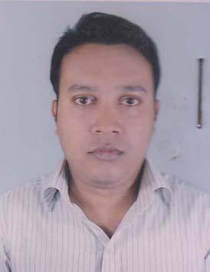 | DR. MD. MEHDI HASAN  F/Name: MD. Wazed Ali  M/Name: Mrs. Mazeda Begum  BM & DC Reg. No: 48290  NID: 1594116381056  Cell: 01719965311  Address: Hamida Dream Castle, Moubag Shimultaly, Gazipur Sadar, Gazipur  Blood Group: O+
132 | Voter No  LM-2000128 | DR. SHANKAR CHANDRA DAS  F/Name: Ananda Chandra Das  M/Name: Charubala Das  BM & DC Reg. No: 28355  NID: 0695112193140  Cell: 01711402795  Address: 44/8, Baghmara, Mymensingh  Blood Group: O+
133 | Voter No  LM-2000129  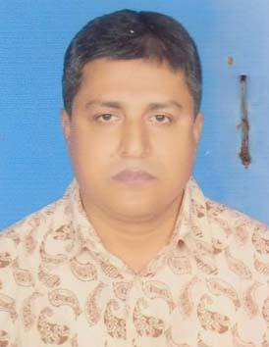 | DR. SUSHANTA KUMAR SARKAR  F/Name: Lal Mohan Sarkar  M/Name: Mina Rain Sarkar  BM & DC Reg. No: 27830  NID:  Cell: 01716019114  Address: Nalgeni, Chandana, Gazipur  Blood Group: A+
134 | Voter No  LM-2000130 | DR. MD. MAMUN UR RASHID  F/Name: Md. Yousuf Ali  M/Name: Farida Begum  BM & DC Reg. No: 51781  NID: 3323019454954  Cell: 01715873168  Address: UHC, Kaliakoir  Blood Group: B+
135 | Voter No  LM-2000131  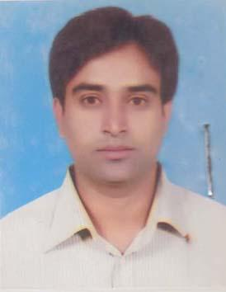 | DR. ASIM CHANDRA GHOSH  F/Name: Anil Chandra Ghosh  M/Name: Saya Rani Ghosh  BM & DC Reg. No: 46032  NID:  Cell: 01916541782  Address: Sadar Hospital, Gazipur  Blood Group: O+
136 | Voter No  LM-2000132  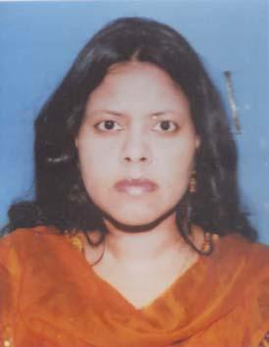 | DR. MAFRUHA SULTANA  F/Name: Md. Mojibur Rahman  M/Name: Akhter Ara Begum  BM & DC Reg. No: 49357  NID: 8524904042161  Cell: 01716157502  Address: A/1, Regal Heights, South Kalyanpur, Dhaka  Blood Group: A+
137 | Voter No  LM-2000133  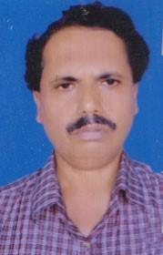 | DR. TAPAN KANTI SARKAR  F/Name: Late Nimai Krishna Sarkar  M/Name: Sabita Rani Sarkar  BM & DC Reg. No: 18626  NID: 3323007159232  Cell: 01712221651  Address: Resident Medical Officer (RM) Sadar Hospital, Gazipur  Blood Group: B+
138 | Voter No  LM-2000134 | DR. MOHAMMAD SHOHAL RANA  F/Name: Mohammad Kafil Uddin  M/Name: Late Mrs. Sumola Khaton  BM & DC Reg. No: 41456  NID: 3318657417816  Cell: 01716291709  Address: Insaf Hospital Pvt, Ltd. 2nd floor, Rothkhola Dal , Sadar Hospital Road, Gazipur  Blood Group: A+
139 | Voter No  LM-2000135 | DR. MD. ALI HAIDER KHAN  F/Name: Late, A.k. Mojibur Rahman  M/Name: Momena Begum  BM & DC Reg. No: 14987  NID: 3323004184779  Cell: 01552480802  Address: KA-5, Doctor\'s Quarter, Sadar Hospital Gazipur  Blood Group: A+
140 | Voter No  LM-2000136  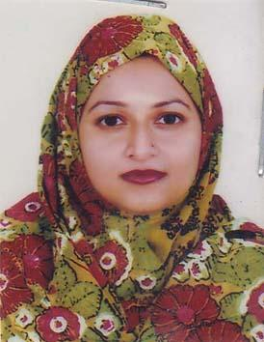 | DR. SHOHELI YESMIN  F/Name: Dr. Muhammed Abdul Hannan Bhuiyan  M/Name: Sufiya Begum  BM & DC Reg. No: 51736  NID: 3323004133320  Cell: 01748465554  Address: 139/C South Chayabethi, Jaydebpur, Gazipur  Blood Group: O+
141 | Voter No  LM-2000137  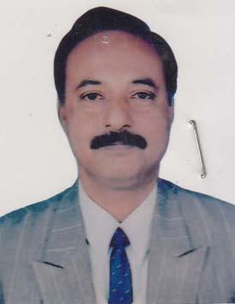 | DR. M.A. HANNAN BHUIYAN  F/Name: Late Md. Abdu Mozid Bhuiyan  M/Name: Late Assirennesa Begum  BM & DC Reg. No: 10490  NID:  Cell: 01711969776  Address: 139/C, South Chaiyabithi, Joydebpur, Gazipur  Blood Group: O+
142 | Voter No  LM-2000138 | DR. MD. MOSTAFA KAMAL HOSSAIN  F/Name: Late Md. Rahmat Ali Bhuiyan  M/Name: Mrs. Saleha Begum  BM & DC Reg. No: 30515  NID:  Cell: 01711160732  Address: House # 5, Road # 2/A, Sector # 5, Uttara; Dhaka  Blood Group: O+
143 | Voter No  LM-2000139  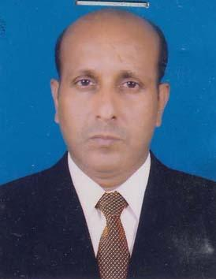 | DR. MD DURUL HODA  F/Name: Md Zaimur Rahman  M/Name: Mst Laily Begum  BM & DC Reg. No: 27963  NID:  Cell: 01711486217  Address: Gazipur Sadar Hospital Gazipur  Blood Group:
144 | Voter No  LM-2000140 | DR. A.K.M MOZAMMEL HOQUE  F/Name: Md. Aman Ullah  M/Name: Ms. Joygoon  BM & DC Reg. No: 20515  NID: 3313266913522  Cell: 01711680919  Address: Block- B-20/2. Chayakunja , South Chaya Bithi, Joydebpur, Gazipur  Blood Group: O+
145 | Voter No  LM-2000141  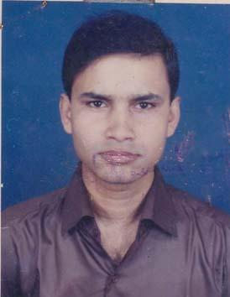 | DR. MOHAMMAD ABDULLAH AL MAMUN  F/Name: Mohammad Martuz Mian  M/Name: Mrs. Amina Begum  BM & DC Reg. No: 38547  NID: 9312877153244  Cell: 01914499783  Address: Kapasia Villa, Outpara, Chandana Chowrasta, Gazipur  Blood Group: B+
146 | Voter No  LM-2000142  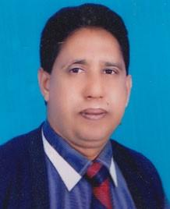 | DR. MD. KAMAR UDDIN  F/Name: Late Sahed Ali  M/Name: Mrs. Julekha Begum  BM & DC Reg. No: 16459  NID:  Cell: 01711984143  Address: E-154/6 Nourth ChhaiyaBeethee, Joydebpur- Gazipur  Blood Group: B+
147 | Voter No  LM-2000143  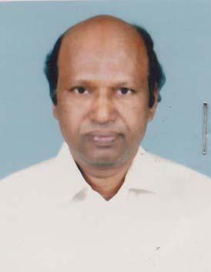 | DR. LIAQUAT ALI KHAN  F/Name: Md. Siddique Ali Khan  M/Name: Hamida Bagum  BM & DC Reg. No: 14914  NID: 3323203810213  Cell: 01199044249  Address: UHC Sreepur, Gazipur  Blood Group: AB_po
148 | Voter No  LM-2000144 | DR. MD. RUHUL FURKAN SIDDIQUE  F/Name: Late Molir Uddin Ahmed  M/Name: Nazat Mohal Siddique  BM & DC Reg. No: 9608  NID:  Cell: 01711154704  Address: Bhai Bhai Medical Hall, Rajbai Road, Gazipur  Blood Group: A+
149 | Voter No  LM-2000145  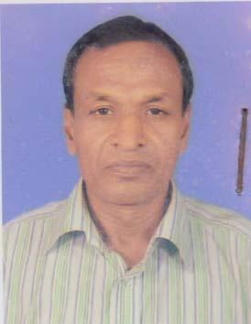 | DR. MD. TAUFIQUR RAHMAN  F/Name: Late Nurul Hossain Mondol  M/Name: Late Shamima Begum  BM & DC Reg. No: 2176  NID:  Cell: 01715538656  Address: Upazilla Health Complex, Kaliakoir, Gazipur UH & F.P.O  Blood Group: AB_po
150 | Voter No  LM-2000146  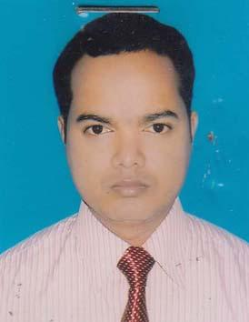 | DR. PRANOY BUSAN DAS  F/Name: Late Dhirendra Chandra Das  M/Name: Pramila Rani Das  BM & DC Reg. No: 50936  NID:  Cell: 01736035230  Address: Vill- Sarayia, Post-Kanayia, Thana-Gazipur Sadar, Gazipur  Blood Group: B+
151 | Voter No  LM-2000147  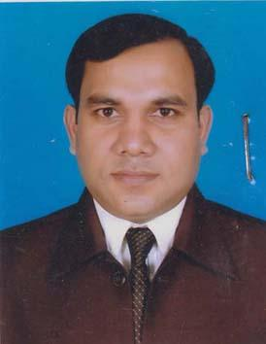 | DR. MD. JAHANGIR ALAM  F/Name: Md. Abul Kashem  M/Name: Meher Banu  BM & DC Reg. No: 41205  NID: 3313060878985  Cell: 01716228047  Address: Vill- Dewliabari, P.O-Konabari, Gazipur Sadar, Gazipur  Blood Group: A+
152 | Voter No  LM-2000148  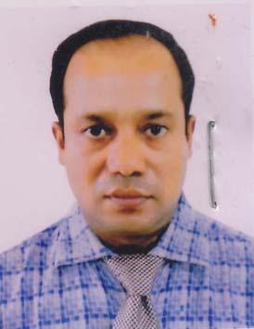 | DR. MD. MOSHFIQUR RAHMAN  F/Name: Afaz Uddin Ahmed  M/Name: Late Mrs. Rowshon Ara Begum  BM & DC Reg. No: 28282  NID:  Cell: 01715331880  Address: Junior Consultent (Anesthesia) Pazipur Sadar Hospital  Blood Group: B+
153 | Voter No  LM-2000149  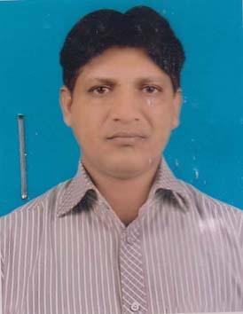 | DR. MOHAMMED ABDUS SALAM SARKER  F/Name: Mohammed Hossain Uddin Sarker  M/Name: Hazi Monowara Hossain  BM & DC Reg. No: 28106  NID: 3313023763409  Cell: 01711737660  Address: Vill: Vogra, Posti National University, Joydebpur, Gazipur  Blood Group: O+
154 | Voter No  LM-2000150  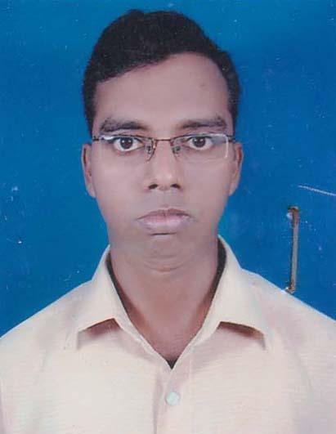 | DR. MOHAMMAD ASHRAF HOSSAIN GAZI  F/Name: Mohammad Abul Hossain Gazi  M/Name: Nurun Nahar  BM & DC Reg. No: 36444  NID: 3313081963219  Cell: 01712503384  Address: Vill: Talinagar, P.O: Haydarabad, P.s: Jaidebpur, Dist: Gazipur  Blood Group: A+
155 | Voter No  LM-2000151  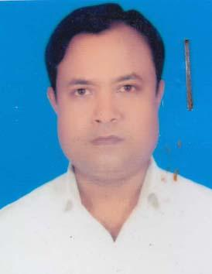 | DR. AKM HAZRAT ALI  F/Name: Md. Taimuddin Sarker  M/Name: Mrs. Jarina Akter  BM & DC Reg. No: 27521  NID: 3313023735472  Cell: 01726644525  Address: Vill: Anandodeep Housing Complex, 14/D, Chandona, Gazipur  Blood Group: B+
156 | Voter No  LM-2000152  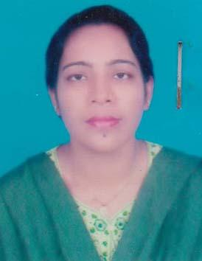 | DR. JUBAIDA SULTANA  F/Name: Late Amirul Islam  M/Name: Zahida Akter  BM & DC Reg. No: 47328  NID: 3313023735473  Cell: 01712175230  Address: 14/d Anandadeep Housing Complex Chandana, Chowrasta, Joydevpur, Gazipur  Blood Group: AB_po
157 | Voter No  LM-2000153 | DR. PARVAZE HOSSAIN  F/Name: Mohammed Motior Rahman  M/Name: Aymon Nesha Rahman  BM & DC Reg. No: 37587  NID: 3313081942674  Cell:  Address: 50 Reded Hospital, Tongi, Gazipur  Blood Group: O+
158 | Voter No  LM-2000154  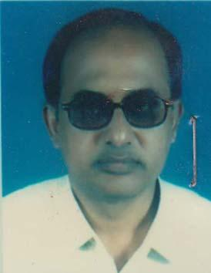 | DR. A.K.M. NURUZZAMAN  F/Name: Late Bazrak Ali Khan  M/Name: Mos. Suraiya Begum  BM & DC Reg. No: 12903  NID: 1022010241350  Cell: 01711438081  Address: 50 Beded Hospital, Tongi, Gazipur  Blood Group: O+
159 | Voter No  LM-2000155  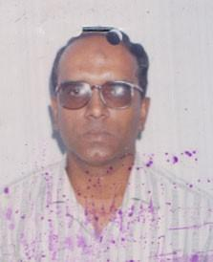 | DR. NAZRUL ISLAM  F/Name: Kalim Uddin Ahmed  M/Name: Rahela Khatun  BM & DC Reg. No: 10737  NID:  Cell: 01712048767  Address: Upazilla Health Complex Kaliganj, Gazipur  Blood Group:
160 | Voter No  LM-2000156 | DR. SUMSUN NAHAR  F/Name: Mohammed Samsuddin  M/Name: Mrs. Jorna Akter  BM & DC Reg. No: 38189  NID: 3323016396748  Cell: 01711579640  Address: Se-10, House-7, Road-16, Uttara  Blood Group: B+
161 | Voter No  LM-2000157  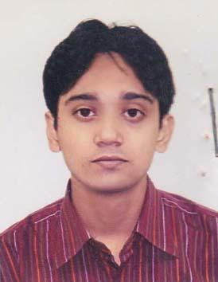 | DR. MD. MAMUN-OR-RASHID IBNE HARUN  F/Name: Mohammed Harun-or-rashid  M/Name: Begum Rokeya Harun  BM & DC Reg. No: 36840  NID:  Cell: 01717039959  Address: 4, Maiz Uddin Ahmed Road, Vill- Dattapara, P.O-Islampur, P.S- Tongi, Dist.- Gazipur  Blood Group: A+
162 | Voter No  LM-2000158 | DR. MUHAMMAD MIZANUR RAHMAN  F/Name: Muhammed Mukbul Hossain  M/Name: Monwara Begum  BM & DC Reg. No: 47456  NID:  Cell: 01712576827  Address: Konalari, Nilnagar, Gazipur Sadar, Gazipur  Blood Group: O-
163 | Voter No  LM-2000159 | DR. MD. IFTEKHER HOSSAIN SIRAJEE  F/Name: Dr. Ismail Hossain Sirajee  M/Name: Mrs. Hasna Hena Sirajee  BM & DC Reg. No: 52310  NID: 1315894661043  Cell: 01744492748  Address: Flat# w/2, House#09, Ishakhan Avenue, Sector#06, Uttara, Dhaka-1230  Blood Group: AB_po
164 | Voter No  LM-2000160  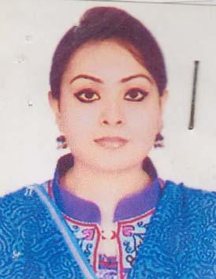 | DR. BUSHRA TANZEM  F/Name: Prof.(dr) Md. Shah Alam  M/Name: Momotaz Begum  BM & DC Reg. No: 51205  NID: 2693622276691  Cell: 01716058978  Address: Flat no# w-2, H# 9, Isha Khan Avenue Sector-6, Uttara, Dhaka  Blood Group: B+
165 | Voter No  LM-2000161  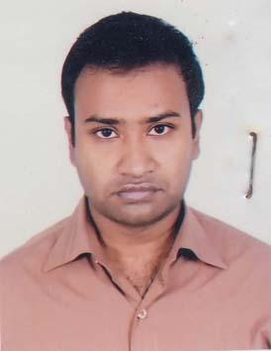 | DR. MD. MAHBUBUR RAHMAN  F/Name: Abdur Rahman  M/Name: Minuara Begum  BM & DC Reg. No: 50601  NID: 2693622448037  Cell: 01680122339  Address: Vill: Bohuria Challa, Post: Mirzapur Bazar, Upozilla: Joidebpur, Dist: Gazipur  Blood Group: B+
166 | Voter No  LM-2000162  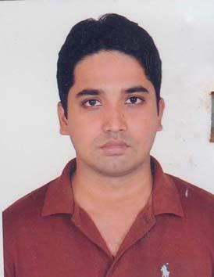 | DR. MD. SALAH UDDIN TAREQ  F/Name: Dr. Md. Delowar Hossain  M/Name: Hosneara Begum  BM & DC Reg. No: 54223  NID: 3323007167724  Cell: 01712865454  Address: House no. 181, Block-E, Uttarchayabithi, Joydebpur, Gazipur  Blood Group: B+
167 | Voter No  LM-2000163 | DR. KHONDAKER MAHBUB ELAHI  F/Name: Khondaker Abdus Satter  M/Name: Mrs. Jakia Satter  BM & DC Reg. No: 53207  NID: 3323011305961  Cell: 01716095581  Address: IMC, Gusulia, Tongi, Gazipur  Blood Group: O+
168 | Voter No  LM-2000164 | DR. MOHAMMAD MASUD RANA  F/Name: Ali Ahammed  M/Name: Fatema Begum  BM & DC Reg. No: 44608  NID: 3323017415928  Cell: 01712020793  Address: 23, Shohid Smrity School Road, Vill- East Aricha, P.s.- Tongi, P.O.- Monnonagar, Dist- Gazipur  Blood Group: O+
169 | Voter No  LM-2000165 | DR. SHAZLY BARI  F/Name: Adv. M.A. Bari  M/Name: Shireen Bari  BM & DC Reg. No: 50164  NID: 2619551692273  Cell: 01737295581  Address: H-6, R- 4, Sec-13, Uttara, Dhaka  Blood Group: O+
170 | Voter No  LM-2000166  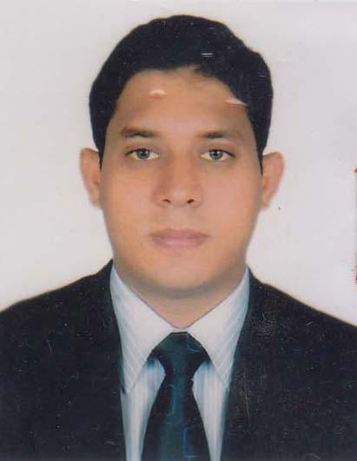 | DR. MD. RASHEDUZZAMAN  F/Name: Md. Ataur Rahman  M/Name: Mrs. Karuna Begum  BM & DC Reg. No: 47473  NID: 3313031805470  Cell: 01727307294  Address: Vill: Kamarganj, Post- National University, PS- Gazipur Sadar, Dist- Gazipur  Blood Group: O+
171 | Voter No  LM-2000167 | DR. PRODIP KUMAR SARKER  F/Name: Late Jogesh Chandra Sarker  M/Name: Late Charu Prova Sarker  BM & DC Reg. No: 9448  NID: 2692620641487  Cell: 01716417999  Address: Deputy Director, Sir Salimullah Medical College Mitford Hospital, Dhaka  Blood Group: B+
172 | Voter No  LM-2000168  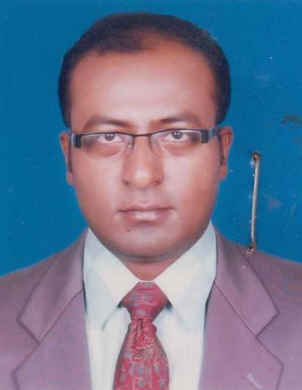 | DR. MD. ABDUL MUKIT  F/Name: Md. Zamir Ali  M/Name: Mrs. Ayesha Akter  BM & DC Reg. No: 42069  NID: 3323016377534  Cell: 01711130593  Address: Vill: Arichpur(Natun Bazar), P.O- Monnu Nagar, P.S- Tongi, Dist.- Gazipur  Blood Group: O+
173 | Voter No  LM-2000169  No Image | DR. SHEIKH LUTFOR RAHMAN  F/Name:  M/Name:  BM & DC Reg. No:  NID:  Cell: 01712650006  Address: C/1/6, South Shyabithi, Joydebpur, Gazipur.  Blood Group:
174 | Voter No  LM-2000170  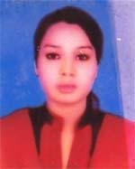 | DR. SALMA ANJUM  F/Name: Mohammad Hossain  M/Name: Hosne Ara Begum  BM & DC Reg. No: 62076  NID:  Cell: 01768033336  Address: Ward No.-27, 72/5, Laxmipura, Gazipur, Municipality, Gazipur  Blood Group: AB+
175 | Voter No  LM-2000171 | DR. ASHISH KUMAR BANIK  F/Name: Mahadeb Chandra Banik  M/Name: Shikha Banik  BM & DC Reg. No: 45625  NID: 2619551164765  Cell: 01971163393  Address: H # 22, Z # 10, Sec # 11, Uttara-1230, UHC, Kaliganj, Gazipur  Blood Group: O+  E X P I R E D
176 | Voter No  LM-2000172 | DR. IRIN SULTANA  F/Name: Lutfur Rahman  M/Name: Mahmuda Akhter  BM & DC Reg. No: 48196  NID: 2696828808393  Cell: 01718128032  Address: 135/4, Block-C, South Chyabithi, Joydebpur, Gazipur  Blood Group: B+
177 | Voter No  LM-2000173 | DR. TARIQ HASSAN  F/Name: Sadrul Amin  M/Name: Nazmun Nahar  BM & DC Reg. No: 44328  NID: 19792691650147208  Cell: 01712594589  Address: House No.-10, Road No.-31B, Sector-9, Uttara, Dhaka-1230  Blood Group: A+
178 | Voter No  LM-2000174  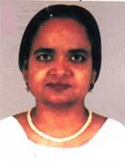 | DR. MST. ALEYA KHATUN  F/Name: Md. Momez Uddin Sarkar  M/Name: Mst. Ayesha Khatun  BM & DC Reg. No: 21741  NID: 2699501910342  Cell: 01715614746  Address: House # 37, Road # 5, Sector # 11, Uttara, Dhaka  Blood Group: O+
179 | Voter No  LM-2000175  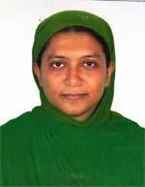 | DR. SHAMSOON NAHAR  F/Name: Md. Aminul Islam  M/Name: Ayesha Begum  BM & DC Reg. No: 26647  NID: 19707528704123721  Cell: 01745791492  Address: Kaliganz Upazilla Health Complex, Kaliganz, Gazipur  Blood Group: A+
180 | Voter No  LM-2000176 | DR. MD. MOSADDEQUE HASAN ASIF  F/Name: Zulfiqar Hasan  M/Name: Monowara Begum  BM & DC Reg. No: 57324  NID: 2650898251925  Cell: 01685292794  Address: House-140, Road-22, New Dohs, Mohakhali, Dhaka  Blood Group: O+
181 | Voter No  LM-2000177 | DR. SHABBIR AHAMED BHUIYAN  F/Name: Md. Abdus Samad Bhuiyan  M/Name: Nazmun Nahar  BM & DC Reg. No: 56458  NID: 19876125217227327  Cell: 01818041568  Address: K-41/1, Shohid Neyamor Shorok West Bilashpur, Gazipur Sadar, Gazipur  Blood Group: AB+
182 | Voter No  LM-2000178  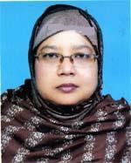 | DR. ZAHIRUN NESSA  F/Name: Md. Jalal Uddin  M/Name: Mrs. Rabeya Khatun  BM & DC Reg. No: 25077  NID: 3318625708982  Cell: 01713530248  Address: Junior Cons. Upazilla Health Complex, Sreepur, Gazipur  Blood Group: B+
183 | Voter No  LM-2000179  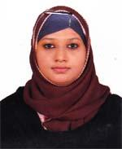 | DR. MAHJABIN ALAM MOURY  F/Name: Md. Zahangir Alam  M/Name: Motinur Begum Mala  BM & DC Reg. No: 66389  NID: 3328601006356  Cell: 01759968268  Address: House-15, Road-30, Section-7, Uttara, Dhaka  Blood Group: B+
184 | Voter No  LM-2000180 | DR. MD. MOHSIN TAREQ  F/Name: Late Nasir Uddin Ahmed  M/Name: Shultana Asma  BM & DC Reg. No: 57382  NID: 3323004144784  Cell: 01715158343  Address: G-40, Saha Para, Gazipur-1700, Gazipur Sadar, Gazipur  Blood Group: O+
185 | Voter No  LM-2000181  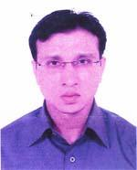 | DR. MD. MOKADDEM HOSSEN  F/Name: Late Md. Abdul Hakim Molla  M/Name: Monoara Begum  BM & DC Reg. No: 50675  NID: 19828115367430521  Cell: 01716929334  Address: 270/6, Varam , Gazipur Sadar, Gazipur  Blood Group: O+
186 | Voter No  LM-2000182 | DR. MAHMUDA NAHER  F/Name: Md. Omar Ali  M/Name: Kamrun Nahar  BM & DC Reg. No: 36852  NID: 3323004135303  Cell: 01712073991  Address: D/190, Jorpohurpar, Joydebpur, Gazipur  Blood Group: O+
187 | Voter No  LM-2000183 | DR. A. S. M. FAZLUL HAQUE  F/Name: Md. Nazrul Islam  M/Name: Sufia Khatun  BM & DC Reg. No: 56405  NID: 19882924709173077  Cell: 01616526526  Address: Vill-Dhanua (Nagar Hawla), Post-Gazipur, Upazilla-Sreepur, Dist-Gazipur  Blood Group: A+
188 | Voter No  LM-2000184  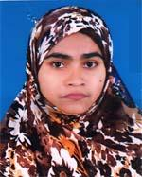 | DR. JULEKHA BEGUM  F/Name: Md. Jalal Uddin Mollah  M/Name: Roheya Begum  BM & DC Reg. No: 53880  NID: 1985695112193589  Cell: 01792224849  Address: 170/6, Vora, Gazipur Sadar, Gazipur  Blood Group: AB+
189 | Voter No  LM-2000185 | DR. SADIKATUL TAHIRIN  F/Name: Late Md. Golam Kibria  M/Name: Afia Begum  BM & DC Reg. No: 59203  NID: 8524904042554  Cell: 01717413544  Address: E-126/2, Lalmati, Uttarcayabithi, Gazipur  Blood Group: B+
190 | Voter No  LM-2000186  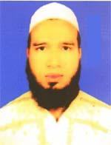 | DR. MD. MAHMUDUR RAHMAN  F/Name: Md. Matiur Rahman  M/Name: Marzia Rahman  BM & DC Reg. No: 57526  NID: 19876125217227403  Cell: 01965262408  Address: 265/C, South Barobaika, Itahata, Chandona, Gazipur City Corporation, Gazipur  Blood Group: A+
191 | Voter No  LM-2000187  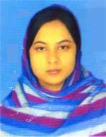 | DR. REHENA AKTER  F/Name: Md. Helal Uddin Sarker  M/Name: Mrs. Nazma Akter  BM & DC Reg. No: 52162  NID: 3313067604563  Cell: 01915490236  Address: Lecturer Shahed Tajuddin Ahmad Medical College, Gazippur  Blood Group: B+
192 | Voter No  LM-2000188  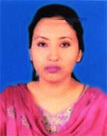 | DR. HAFSA KHANOM  F/Name: Md. Hazrat Ali  M/Name: Ambia Khaton  BM & DC Reg. No: 51701  NID: 3323013587992  Cell: 01912022402  Address: Shamantapur, Gazipur City Corporation, Gazipur  Blood Group: O+
193 | Voter No  LM-2000189 | DR. MOHAMMAD MONIRUZZAMAN  F/Name: Mohammad Mohiuddin  M/Name: Mrs. Monowara Begum  BM & DC Reg. No: 61111  NID: 19833323018440162  Cell: 01678158159  Address: Vill-Gopalpur, P.s-Tongi, Post-Monnonagar, Dist-Gazipur  Blood Group: AB+
194 | Voter No  LM-2000190  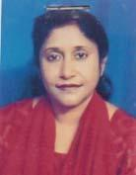 | DR. NARGIS RAHMAN  F/Name: Abdur Rahman Mollah  M/Name: Hurun Nahar  BM & DC Reg. No: 14045  NID: 19592642619563048  Cell: 01715468728  Address: Apt. 5/A, House-24, Road -11, Sector-11, Uttara, Dhaka  Blood Group: B+
195 | Voter No  LM-2000191 | DR. AHAMADUZ ZAMAN  F/Name: Ansar Uddin Joardar  M/Name: Mst. Hamida Banu  BM & DC Reg. No: 14044  NID: 19582692619563047  Cell: 01711423632  Address: Apt. 5/A, House-24, Road-11, Sector-11, Uttara, Dhaka  Blood Group: B+
196 | Voter No  LM-2000192 | DR. SHARMIN JAHAN URMI  F/Name: Late Md. Oaliullah  M/Name: Mrs. Sanjet Ara Begum  BM & DC Reg. No: 33627  NID: 2692619559119  Cell: 01711171200  Address: House No.-11, Road-05, Sector-6, Uttara  Blood Group: B+
197 | Voter No  LM-2000193 | DR. MOHAMMED ZUBAYER MIAH  F/Name: Late Mohammed Shamsuzzuha  M/Name: Syeda Howa Begum  BM & DC Reg. No: 33230  NID: 2696402505018  Cell: 01716196737  Address: Shaheed Tazuddin Ahmad Medical Col-lege, Gazipur.  Blood Group: B+
198 | Voter No  LM-2000194  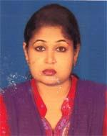 | DR. MAHBUBA SULTANA  F/Name: Mir Momtaz Uddin  M/Name: Fatema Begum  BM & DC Reg. No: 52395  NID: 8524904042809  Cell: 01712117118  Address: K9/15, West Bilaspur, Joydebpur, Gazipur  Blood Group: O+
199 | Voter No  LM-2000195  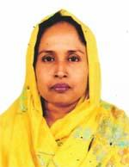 | DR. MOST. FATIMA DOLON  F/Name: Md. Delwar Hossain  M/Name: Maleka Khanom  BM & DC Reg. No: 18584  NID: 2611038720653  Cell: 01711546038  Address: Fatima Bhaban, 26, Girls School Road, Dhakkin Khan, Dhaka  Blood Group: B+
200 | Voter No  LM-2000196 | DR. MOHAMMAD MAINUL ISLAM  F/Name: Late Hasen Ali  M/Name: Late Maleka Begum  BM & DC Reg. No: 31924  NID: 2697556418156  Cell: 01712160609  Address: United General Hospital, Hossain Market, Tongi, Gazipur  Blood Group: A+
201 | Voter No  LM-2000197  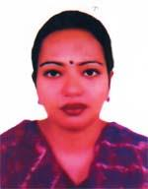 | DR. ISHRAT JAHAN  F/Name: Md. Yusuf Mia  M/Name: Rehena Begum  BM & DC Reg. No: 45373  NID: 19826720602256315  Cell: 01711581086  Address: Moholla-Dewliabari, Post-Konabari, P.s-Gazipur Sadar, Dist-Gazipur  Blood Group: AB+
202 | Voter No  LM-2000198 | DR. MD. DELWAR HOSSAIN  F/Name: Md. Abul Hossain  M/Name: Delwara Begum  BM & DC Reg. No: 66040  NID: 3313257984851  Cell: 01920161748  Address: Begumpur, Shakaswar Kaliakair, Gazipur  Blood Group: AB+
203 | Voter No  LM-2000199  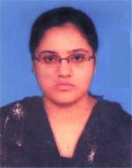 | DR. LIPI RANI SHAHA  F/Name: Doyal Chandro Shaha  M/Name: Purnima Rani Saha  BM & DC Reg. No: 62429  NID: 6125206146786  Cell: 01711052999  Address: 179/A, Hazibagh, Gazipur Sadar  Blood Group: O+
204 | Voter No  LM-2000200 | DR. DILIP KUMAR MALLIK  F/Name: Haran Chandra Mallik  M/Name: Dipali Rani Mallik  BM & DC Reg. No: 40825  NID: 3323005149607  Cell: 01711052999  Address: 179/A, Hazibagh Market, Gazipur, Sadar  Blood Group: B+
205 | Voter No  LM-2000201 | DR. EVA SEN  F/Name: Bijoy Sen  M/Name: Monju Sen  BM & DC Reg. No: 62300  NID: 3323018446447  Cell: 01739782178  Address: 25/1, Pager, Tongi, Gazipur  Blood Group: B+
206 | Voter No  LM-2000202 | DR. MD. ASHRAFUL ALAM  F/Name: Late Abdul Jabbor  M/Name: Late Majiron Begum  BM & DC Reg. No: 15156  NID: 2619556166545  Cell: 01711526267  Address: Sr-Consult. Surgeon, Stamcbt.  Blood Group: A+
207 | Voter No  LM-2000203  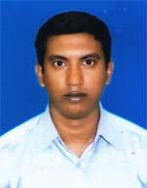 | DR. MD. AFJAL HOSSAIN  F/Name: Md. Helal Uddin  M/Name: Sufia Begum  BM & DC Reg. No: 75072  NID: 19913323019000268  Cell: 01676712588  Address: H/O-262, Kuddus Khalifa Road, Morkun, Tongi, Gazipur, City Corporation, Ward No.-47  Blood Group: O+
208 | Voter No  LM-2000204 | DR. MD. ANISUZZAMAN  F/Name: Md. Mofiz Uddin  M/Name: Mrs. Anowara Begum  BM & DC Reg. No: 48249  NID: 2611038830907  Cell: 01715029546  Address: Vill-sharifpur, Post-National University, Thana-Gazipur Sadar, Dist-Gazipur  Blood Group: O+
209 | Voter No  LM-2000205 | DR.MOHAMMAD MAZHARUL ISLAM (MUKUL)  F/Name: Mohammad Nurul Islam  M/Name: Mamataz Begum  BM & DC Reg. No: 66771  NID: 19883313031861353  Cell: 01971125240  Address: Village-Ishadda, Post-National University, Thana-Gazipur Sadar, Dist-Gazipur  Blood Group: B+
210 | Voter No  LM-2000206 | DR. MD. RAFIUR RAHMAN BANI  F/Name: Md. Rakibur Rahman  M/Name: Rokeya Rahman  BM & DC Reg. No: 71685  NID: 19903323005000093  Cell: 01670925103  Address: 18/1, Rajbagan Road, Noagong, Gazipur Sadar, Gazipur  Blood Group: AB+
211 | Voter No  LM-2000207 | DR. QAZI MD. SALAH UDDIN  F/Name: Late Alhaj Qazi Md. Jamal Uddin  M/Name: Monowara Begum  BM & DC Reg. No: 52809  NID: 3323014351576  Cell: 01711118188  Address: 71, Qazi Bari, Masimpur Station Road, Medical gate, Tongi, Gazipur  Blood Group: O+
212 | Voter No  LM-2000208  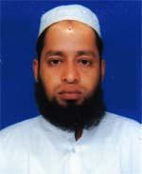 | DR. MUHAMMAD MOSTAFIZUR RAHMAN KHAN  F/Name: Md. Ibrahim Khan  M/Name: Monwara Khan  BM & DC Reg. No: 50630  NID:  Cell: 01712510998  Address: House No.-780, Word No.-34, Vill-Sharifapur, Post-National University, Dist-Gazipur  Blood Group: B+
213 | Voter No  LM-2000209 | DR. TANIYA CHOWDHURY  F/Name: Late Shah Alom Chowdhury  M/Name: Samsun Nahar  BM & DC Reg. No: 58844  NID:  Cell: 01940396538  Address: 71, Qazi Bari, Masimpur, Station Road, Medical gate, Tongi, Gazipur  Blood Group: O+
214 | Voter No  LM-2000210 | DR. MD. SALIM SHAHED  F/Name: Abdul Matin  M/Name: Shamsun Nahar  BM & DC Reg. No: 41396  NID:  Cell: 01711245695  Address: Avizan 21, Auch Para, Tongi Gazipur.  Blood Group: B+
215 | Voter No  LM-2000211 | DR. ELIZA SULTANA  F/Name: Mahbubar Rahman  M/Name: Hasinara Begum  BM & DC Reg. No: 41805  NID:  Cell: 01712086490  Address: Avizan 21, Auchpara, Tongi, Gazipur.  Blood Group: O+
216 | Voter No  LM-2000212  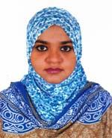 | DR. SHARMIN RAHMAN  F/Name: Dr. Mujibur Rahman  M/Name: Dr. Ferdousi Begum  BM & DC Reg. No: 67520  NID:  Cell: 01755654270  Address: Abeda Memorial Hospital, Station road, Tongi, Gazipur  Blood Group: AB+
217 | Voter No  LM-2000213  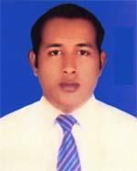 | DR. REDUAN AHAMMED  F/Name: Kazim Uddin Ahammed  M/Name: Rokeya Akter  BM & DC Reg. No: 63174  NID: 3313660099333  Cell: 01686602437  Address: House No.-614, Moushi Bari Road, National University, Board Bazar, Gazipur  Blood Group: O+
218 | Voter No  LM-2000214 | DR. MOHAMMAD RAFIQUL ISLAM  F/Name: Mohammad Shmshuddin  M/Name: Rahima Begum  BM & DC Reg. No: 37639  NID:  Cell: 01912020663  Address: Medical Officers, Stamch, Gazipur.  Blood Group: AB+
219 | Voter No  LM-2000215 | DR. MD. ASRAFUL ISLAM  F/Name: Md. Akram Molla  M/Name: Rahima Begum  BM & DC Reg. No: 62528  NID: 1916765152951  Cell: 01677424362  Address: UHC-Kaligonj, Gazipur  Blood Group: B+
220 | Voter No  LM-2000216 | DR. MD. KAWSARUL ISLAM  F/Name: Late Nazrul Islam  M/Name: Kolsum Akter  BM & DC Reg. No: 58665  NID: 3313266902406  Cell: 017166633897  Address: Holding No.-385, Road No.-3, Vill-Telirchala, Post-Mouchak-1751, Upazilla-Kaliakoir, Dist-Gazipur  Blood Group: B+
221 | Voter No  LM-2000217 | DR. MD. MAHBUBUR RAHMAN  F/Name: Md. Nurul Islam  M/Name: Maksuda Khatun  BM & DC Reg. No: 61672  NID: 3313054715952  Cell: 01717696450  Address: Vill-South Salna, Post-Salna bazar, Gazipur Sadar, Gazipur  Blood Group: B+
222 | Voter No  LM-2000218 | DR. MOHAMMAD SADEQUR RAHMAN AKANDA  F/Name: Mohammad Anwar Hossain  M/Name: Mst. Masuda Begum  BM & DC Reg. No: 38392  NID: 33134586605120  Cell: 01711962312  Address: Vill-Uttar Bhaderti, Post+Thana-Kaligonj, Dist-Gazipur  Blood Group: A+
223 | Voter No  LM-2000219  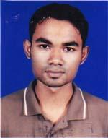 | DR. ARUP KUMAR DAS  F/Name: Pratap Kumar Das  M/Name: Anita Rani Das  BM & DC Reg. No: 63244  NID: 1594116722159  Cell: 01719097840  Address: Upazilla Health Complex, Kaligang, Gazipur  Blood Group: B+
224 | Voter No  LM-2000220  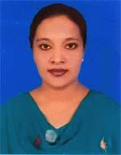 | DR. FAIZUNNAHAR  F/Name: Fazlul Bari  M/Name: Kamrun Nahar  BM & DC Reg. No: 53578  NID: 19853313031808056  Cell: 01923284343  Address: Vill-Chandara, Post-Gacha, Thana-Gazipur Sadar, Dist-Gazipur  Blood Group: B+
225 | Voter No  LM-2000221  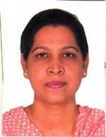 | DR. BEGUM FERDOUSY  F/Name: S. M. Abdul Gaffar  M/Name: Begum Mahbuba  BM & DC Reg. No: 24456  NID: 2699501914945  Cell: 01717206272  Address: House-15, Road-4, Sec-10, Uttara, Dhaka  Blood Group: O+
226 | Voter No  LM-2000222 | DR. MD. SALEH FAISAL  F/Name: Md. Abdul Bari  M/Name: Mrs. Meherunnessa  BM & DC Reg. No: 46914  NID: 3328601005436  Cell: 01711158550  Address: Imo, Medicine, Sir Salimullah Medical College & Mitford Hospital, Dhaka  Blood Group: A+
227 | Voter No  LM-2000223 | DR. RATIM MIR  F/Name: Abdul Baten Mir  M/Name: Shahida Parvin  BM & DC Reg. No: 62788  NID: 8198510364644  Cell: 01913068929  Address: Vill-Borosit, Post-Tilsunia, P.s-Kapasia, Dist-Gazipur  Blood Group: AB+
228 | Voter No  LM-2000224 | DR. MOHAMMED SAIFUL ISLAM  F/Name: Mohammed Mofiz Uddin  M/Name: Anowara Begum  BM & DC Reg. No: 41508  NID: 3313060920193  Cell: 01716299408  Address: 200/3, Block-F, North Chayabithi, Joydevpur, Gazipur  Blood Group: B+
229 | Voter No  LM-2000225  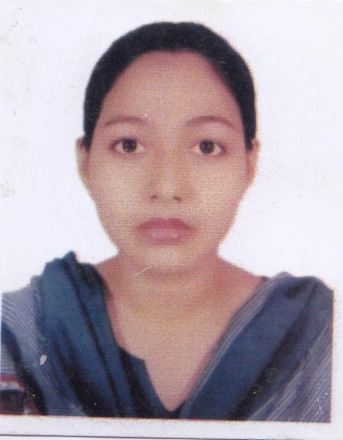 | DR. JASMIN RAHMAN  F/Name: Abdur Rahman  M/Name: Farida Rahman  BM & DC Reg. No:  NID: 2697683236368  Cell:  Address: Thana-Gazipur Sadar, Dist-Gazipur.  Blood Group: O+
230 | Voter No  LM-2000226  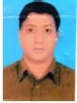 | DR. SAIFUL ISLAM  F/Name: Md. Junab Ali  M/Name: Salma Begum  BM & DC Reg. No: 60478  NID: 0965111184738  Cell: 01717403252  Address: Vannara, Mouchak, Kaliakoir, Gazipur  Blood Group: B+
231 | Voter No  LM-2000227 | DR. NAZIAH RAHMAN CHOWDHURY TANIA  F/Name: Md. Habibur Rahman Chowdhury  M/Name: Anjuman Ara Begum  BM & DC Reg. No: 61135  NID: 2693016125295  Cell: 01719038235  Address: Upazilla Health Complex, Sreepur, Gazipur  Blood Group: AB+
232 | Voter No  LM-2000228  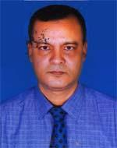 | DR. MOLLAH MD. MATIUR RAHMAN  F/Name: Md. Sahad Ali Mollah  M/Name: Mrs. Zubaida Khaton  BM & DC Reg. No: 16303  NID: 3323003114749  Cell: 01711196382  Address: Anaesthesiologist, (Deputation) 50 Beded Tongi Hospital, Gazipur  Blood Group: B+
233 | Voter No  LM-2000229 | DR. MD. IMRAN KHAN  F/Name: Md. Hafizullah Chowdhury  M/Name: Rabeya Begum  BM & DC Reg. No: 56718  NID: 3323022521678  Cell: 01719958011  Address: Dattapara, House Building, Tongi, Gazipur  Blood Group: B+
234 | Voter No  LM-2000230 | DR. MAUIN UDDIN  F/Name: Jahir Ahmed  M/Name: Ruby Ahmed  BM & DC Reg. No: 46837  NID: 2610482088380  Cell: 01747617997  Address: Ward-3, Holding-12, Salamat Molla Road, Uttar Auchpara, Tongi, Gazipur  Blood Group: A+
235 | Voter No  LM-2000231 | DR. NASRIN SULTANA  F/Name: Md. Rezaul Karim  M/Name: Shefali Yesmin  BM & DC Reg. No: 56680  NID: 8524904052551  Cell: 01737983044  Address: House No. 664, Great Wall city , Naljani Joydebpur, Gazipur  Blood Group: O+
236 | Voter No  LM-2000232 | DR. MAHBUB E KHODA  F/Name: Late Md. Altaf Hossain  M/Name: Mrs. Rajia Khaton  BM & DC Reg. No: 37275  NID: 19745027909000002  Cell: 01751865761  Address: Gazipur, Diabetic Society  Blood Group: O+
237 | Voter No  LM-2000233 | DR. ABU ZAFAR MUHAMMAD KHAIRUL ANAM  F/Name: Muhammad Abul Hashem  M/Name: Rehana Sultana  BM & DC Reg. No: 38239  NID: 3323003113297  Cell: 01714085295  Address: Block K-67, Bilashpur, Joydebpur, Gcc, Gazipur  Blood Group: O+
238 | Voter No  LM-2000234 | DR. MOHAMMAD MASUD HASAN  F/Name: Late Mr. Abdul Huque  M/Name: Mrs. Rowshan Ara Huque  BM & DC Reg. No: 20471  NID: 2699501911213  Cell: 01727702923  Address: Assit. Prof. Neuro Medicine, Shahged Tajuddin Medical College Hospital, Gazipur  Blood Group: A+
239 | Voter No  LM-2000235 | DR. KHWAJA HABIB SALIM  F/Name: Khwaja Habib Ullah  M/Name: Shahida Habib  BM & DC Reg. No: 24768  NID: 2690243843022  Cell: 01819294843  Address: Department of Paediatric Surgery, Shaheed Tazuddin Ahmad Medical College, Gazipur  Blood Group: B+
240 | Voter No  LM-2000236 | DR. AZRINA AFRINE  F/Name: Abdul Kader  M/Name: N/a  BM & DC Reg. No: 54752  NID:  Cell: 01912636265  Address: Noagaon, Post-Rajendrapur, Sreepur, Gazipur  Blood Group: AB+
241 | Voter No  LM-2000237  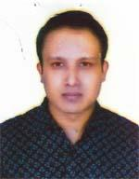 | DR. MOHAMMAD MUSTAFIZUR RAHMAN  F/Name: Mohammad Abdus Shahid  M/Name: Mrs. Nazma Begum  BM & DC Reg. No: 31405  NID: 2613869369584  Cell: 01716507219  Address: House-17, Road-18, Sector-13, Uttara  Blood Group: B+
242 | Voter No  LM-2000238  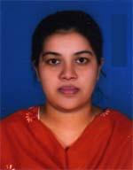 | DR. HABIBA SULTANA  F/Name: Late Mohammad Mukhlesur Rahman  M/Name: Nurunnahar Begum  BM & DC Reg. No: 36369  NID:  Cell: 01711105540  Address: House No.-D-1/2m (Chandina), Bari, Joydebpur, Gazipur  Blood Group: O+
243 | Voter No  LM-2000239 | DR. FARIDA YESMIN  F/Name: Md. Ziaul Haque Gazi  M/Name: N/A  BM & DC Reg. No: 43681  NID: 2627207586365  Cell: 01723917306  Address: 9/2 Banktown (2B), Dalia Yauob Cottage, Savar, Dhaka  Blood Group: O+
244 | Voter No  LM-2000240 | DR. MD. MAHMUDUR RAHMAN DULAL  F/Name: Late Abul Hossain  M/Name: Mst. Suraiya Khatun  BM & DC Reg. No: 45685  NID: 2627207644329  Cell: 01717761650  Address: 9/2 Bandtown (2B), Savar, Dhaka, Dalia Yauob Cottage  Blood Group: B+
245 | Voter No  LM-2000241  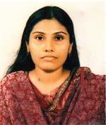 | DR. FARHANA PARVEEN  F/Name: Faiz Uddin Ahmed  M/Name: Nurun Nahar  BM & DC Reg. No: 34963  NID: 2696654368030  Cell: 01766621862  Address: 1/D Gaon Corner, Green Road , Dhaka  Blood Group: O+
246 | Voter No  LM-2000242 | DR. MD. RAJEEB HOSSAIN  F/Name: Abdul Kader Mollah  M/Name: Helena Begum  BM & DC Reg. No: 62439  NID: 3323005146212  Cell: 01775787814  Address: House-123, Hariral, Gazipur-1700, Gazipur  Blood Group: B+
247 | Voter No  LM-2000243  No Image | ***NIL***  F/Name:  M/Name:  BM & DC Reg. No:  NID:  Cell:  Address:  Blood Group:
248 | Voter No  LM-2000244  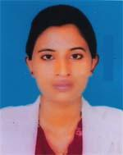 | DR. TANIA SULTANA  F/Name: Late Abdur Razzak  M/Name: Mahmuda Akter  BM & DC Reg. No: 66900  NID: 7217447217097  Cell: 01674349874  Address: Kanchan Villa, Borobari, National University, Gazipur  Blood Group: O+
249 | Voter No  LM-2000245 | DR. PRABIR KUMER SARKER  F/Name: Pronbellav Sarker  M/Name: Bashonti Rani Sarker  BM & DC Reg. No: 45  NID:  Cell: 01770677642  Address: Sheed Tajuddin Ahmed Medical College Hospital, Aneythesiology Dept.  Blood Group: A+
250 | Voter No  LM-2000246 | DR. NASSER MOHAMMAD ALI  F/Name: Habibur Rahman  M/Name: Sultana Khayrun Nessa  BM & DC Reg. No: 76900  NID: 19933323004000267  Cell: 01753333320  Address: G-155, West side of Rajdighi, Joydebpur, Gazipur  Blood Group: AB-
251 | Voter No  LM-2000247 | DR. S. M. IFTEKHER RASUL  F/Name: Md. Idris Ali Lashkar  M/Name: Mrs. Rowshon Ara  BM & DC Reg. No: 57559  NID: 2699501912185  Cell: N/A  Address: H-36, Road-01, Sector-09, Uttara, Dhaka  Blood Group: AB+
252 | Voter No  LM-2000248 | DR. FARHANA MAHBUB  F/Name: Md. Imdadul Haque  M/Name: Aktar Imdad  BM & DC Reg. No: 57560  NID: 2691648035897  Cell: N/A  Address: H-36, Road-01, Sector-09, Uttara, Dhaka  Blood Group: A+
253 | Voter No  LM-2000249  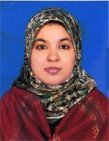 | DR. NURDIDA BINTE AWAL  F/Name: Md. Abdul Awal  M/Name: Hosne Ara Begum  BM & DC Reg. No: 74532  NID: 6129409717993  Cell: 01717633533  Address: 11/5, Jaimat Khan Road, Pagar, Tongi, Gazipur  Blood Group: A+
254 | Voter No  LM-2000250 | DR. SHEIKH MAHMOOD HASAN  F/Name: Sheikh Shiru Mia  M/Name: Hasnara Khatun  BM & DC Reg. No: 77086  NID: 19903323021000381  Cell: 01717357882  Address: South Dattapara(Bank Colony), New-73, Hafiz Uddin Sarker Road, Tongi, Gazipur  Blood Group: B+
255 | Voter No  LM-2000251  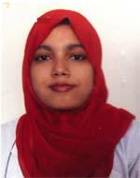 | DR. FATEMA AKTER  F/Name: Md. Harun Ar Rashid  M/Name: Hasina Akter  BM & DC Reg. No: 71532  NID: 5114315214671  Cell: 01733559876  Address: 28/3, Block-F, Babar Road, Johuri Moholla, Mahammadpur, Dhaka  Blood Group: O+
256 | Voter No  LM-2000252  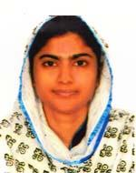 | DR. MST. FAHMODA AKTER  F/Name: Md. Zafar Iqbal  M/Name: Mrs. Shamima Akter  BM & DC Reg. No: 74416  NID:  Cell: 01745656590  Address: 27/19, Jahuri Mahalla, Mohammadpur, Dhaka  Blood Group: A+
257 | Voter No  LM-2000253 | DR. MD. HABIB BAHAR  F/Name: Md. Harunor Rashid  M/Name: Salena Aktar  BM & DC Reg. No: 71569  NID: 19897623903510946  Cell: 01717891036  Address: 28/3, Block-F, Babar Road, Johuri Moholla, Mohammadpur, Dhaka  Blood Group: AB+
258 | Voter No  LM-2000254 | DR. MOHAMMED ABU KAWSAR SARKER  F/Name: Mohammad Shahid Miah Sarker  M/Name: Mamtaz Begum  BM & DC Reg. No: 37794  NID:  Cell: 01710271600  Address: H # 67, R # 18, Sec # 14, Uttara, Dhaka  Blood Group: B+
259 | Voter No  LM-2000255  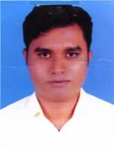 | DR. MOHAMMAD MONIRUZZAMAN  F/Name: Mohammad Joynal Abedin  M/Name: Shahera Begum  BM & DC Reg. No: 78062  NID:  Cell: 01725553737  Address: Barobo, Shakaswer, Kaliabari Gazipur.  Blood Group: O+
260 | Voter No  LM-2000256  No Image | ***NIL***  F/Name:  M/Name:  BM & DC Reg. No:  NID:  Cell:  Address:  Blood Group:
261 | Voter No  LM-2000257 | DR. SHAH ALAM SARKER  F/Name: Abdul Kader Sarker  M/Name: Jahura Begum  BM & DC Reg. No: 54852  NID:  Cell: 01737115740  Address: Doctor\'s Quater, JIMCH, Kishorgonj  Blood Group: O+
262 | Voter No  LM-2000258  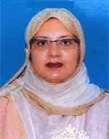 | DR. FERDOUSI BEGUM  F/Name: Md. Anowar Kashem  M/Name: Late Rokeya Begum  BM & DC Reg. No: 38741  NID:  Cell: 01711395309  Address: Anundadip Housing Complex, Chandana, Chowrasta, Gazipur  Blood Group: B+
263 | Voter No  LM-2000259 | DR. RUBANA FORHAD  F/Name: Dr. Md. Forhad Hossain  M/Name: Dr. Tahira Salwa  BM & DC Reg. No: 62155  NID: 2699501925682  Cell: 01753438451  Address: House No.-2, Road-4, Sector-7, Uttara, Dhaka  Blood Group: O+
264 | Voter No  LM-2000260 | DR. MUHAMMAD SHAHEEN  F/Name: Abdul Malake  M/Name: Feroza Begum  BM & DC Reg. No: 37536  NID: 3323021506791  Cell: 01712081751  Address: H-3, R-2, S-11, F 6(W) Uttara, Dhaka  Blood Group: B+
265 | Voter No  LM-2000261  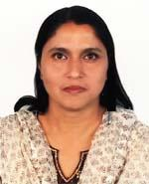 | DR. NASRIN SULTANA  F/Name: Md. Shiraj Uddin Sarker  M/Name: Mrs. Anwara Begum  BM & DC Reg. No: 24505  NID: 3313023753462  Cell: 01711540122  Address: House-17, Road-10, Sector-13, Uttara Model Town, Dhaka  Blood Group: B+
266 | Voter No  LM-2000262 | DR. MONSUR AHMED  F/Name: Late Mofizur Rahman  M/Name: Fukrun Nessa  BM & DC Reg. No: 38081  NID: 3313023739245  Cell: 01711696177  Address: Vill-Outpara, Post-Chandana-1702, Gazipur Sadar, Gazipur  Blood Group: A+
267 | Voter No  LM-2000263  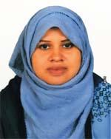 | DR. MATLUBA AKTER  F/Name: Abdur Rashid Shikder  M/Name: Anowara Begum  BM & DC Reg. No: 65502  NID: 3323007165676  Cell: 01732716936  Address: Tin Sharak Luximpura, Joydebpur, Gazipur  Blood Group: O+
268 | Voter No  LM-2000264 | DR. SONIYA SIDDIQUA  F/Name: Md. Abubakr Sidddique  M/Name: Sufia Begum  BM & DC Reg. No: 74205  NID:  Cell: 01732242360  Address: Konabari, Gazipur Sadar, Gazipur  Blood Group: O+
269 | Voter No  LM-2000265 | DR. SOMAYA AKTER  F/Name: Solaiman Kabir  M/Name: Hasina Akter  BM & DC Reg. No: 65067  NID: 2627207628864  Cell: 01924652172  Address: Mouchak, Kaliakoir, Gazipur  Blood Group: A+
270 | Voter No  LM-2000266 | DR. MD. RAKIB HOSSAIN  F/Name: Md. Abdul Bari  M/Name: Shahanaj Bari  BM & DC Reg. No: 73409  NID: 19903313257000234  Cell: 01715520497  Address: Konabari, Gazipur Sadar, Gazipur  Blood Group: B+
271 | Voter No  LM-2000267  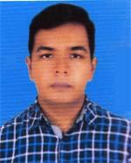 | DR. MEHEDI ASHIK CHOWDHURY  F/Name: N/a  M/Name: N/a  BM & DC Reg. No: 56950  NID:  Cell: N/A  Address: Chandona Chowrasta, Gazipur Sadar, Gazipur  Blood Group: AB+
272 | Voter No  LM-2000268 | DR. NAHID-E-SUBHA  F/Name: Late Nazrul Islam  M/Name: Razin Ara Begum  BM & DC Reg. No: 31394  NID: 2699501929194  Cell: 01552335889  Address: Seba shashrusha Hospital, station Road, Tongi, Gazipur  Blood Group: AB+
273 | Voter No  LM-2000269  No Image | DR. MD. AMJAD HOSSAIN KHAN  F/Name:  M/Name:  BM & DC Reg. No:  NID:  Cell:  Address: Assistant Prof. Of Paediatris Shaheed Tazuddin Ahmmad Medical College, Gazipur.  Blood Group:  TRANSFERED to BMA Dhaka City  LM-1405543
274 | Voter No  LM-2000270 | DR. MOHAMMAD MOSTAFIZUR RAHMAN  F/Name: Shamsuddin Ahmed  M/Name: Asuba Begum  BM & DC Reg. No: 47322  NID:  Cell: 01711588214  Address: House # 9, Road # 16, Sec # 10, Uttara, Dhaka..  Blood Group:
275 | Voter No  LM-2000271 | DR. BIJON KUMAR DAS  F/Name: Sukumar Chandra Das  M/Name: Akul Rani Das  BM & DC Reg. No: 30539  NID: 3343643242387  Cell: 01711577322  Address: Vill-Outpara, Ward No-16, Chandana, Gazipur.  Blood Group: B+
276 | Voter No  LM-2000272  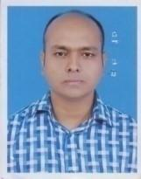 | DR. KIBRIA KABIR  F/Name: A.k.m. Rakibul Islam  M/Name: Shamim Sultana  BM & DC Reg. No: 43935  NID: 2694803583286  Cell: 01717047741  Address: 92/2, Purba Chandona, Gazipur, Dhaka.  Blood Group:
277 | Voter No  LM-2000273 | DR. MD. ABDUS SABUR KHAN  F/Name: Md. Mozemmel Hossain Khan  M/Name: Maleka Khatun  BM & DC Reg. No: 48489  NID: 8524904189432  Cell: 01717452886  Address: House No. 164, Road-2, North Shamoli, West Agargaon, Dhaka.  Blood Group: B+
278 | Voter No  LM-2000274 | DR. MD. HASAN JAMIL IBNE ROUF  F/Name: Md. Abdur Rouf  M/Name: Helena Rouf  BM & DC Reg. No: 61482  NID: 19863313054706533  Cell: 01818079337  Address: Chayabas, Shimultoli, Joydebpur, BOF, Gazipur.  Blood Group: B+
279 | Voter No  LM-2000275 | DR. PANKAJ DAS  F/Name: Dinesh Chandra Das  M/Name: Bina Rani Das  BM & DC Reg. No: 83685  NID: 19923323004000089  Cell: 01922930135  Address: C-110, South Chayabith, Joydebpur, Gazipur.  Blood Group: B+
280 | Voter No  LM-2000276 | DR. AMIT KUMAR ROY  F/Name: Nanda Dulal Roy  M/Name: Nila Roy  BM & DC Reg. No: 76811  NID: 19913323000366  Cell: 01672558872  Address: I-219, North Bilashpur, Joydebpur, Gazipur.  Blood Group: A+
281 | Voter No  LM-2000277 | DR. ZAHIRUL ISLAM  F/Name: Halal Uddin  M/Name: Hosnara  BM & DC Reg. No: 82179  NID: 19923318666000320  Cell: 01922333426  Address: Chinasukhania, Rajabari, Sreepur, Gazipur.  Blood Group: O+
282 | Voter No  LM-2000278  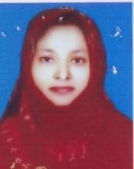 | DR. NASRIN SULTANA  F/Name: Md. Abdul Haque  M/Name: Mrs. Mamotaz Haque  BM & DC Reg. No: 33703  NID: 2650898263886  Cell: 01749666900  Address: Asstt. Professor of Community Medicine, STAMC, Gazipur.  Blood Group: B+
283 | Voter No  LM-2000279  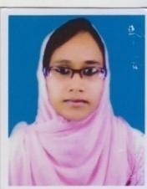 | DR. TAWHIDA BHUIYAN  F/Name: Md. Abdul Khaleque Bhuiyan  M/Name: Mst. Nargis Akter  BM & DC Reg. No: 61042  NID: 19871726709061254  Cell: 01871494764  Address: Lecturer (Pathology), Shahid Taj Uddin Ahmed Medical College, Gazipur.  Blood Group: B+
284 | Voter No  LM-2000280  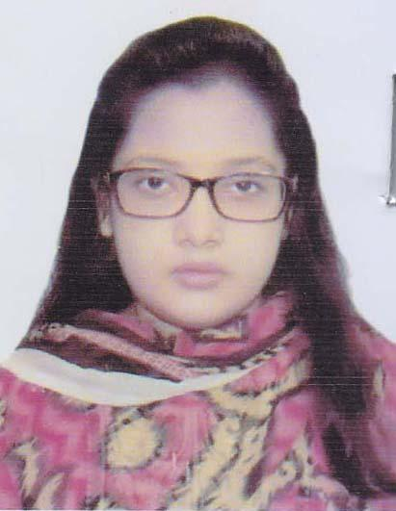 | DR. RABAYA AKTER AKHI  F/Name: Mohammad Khalilur Rahman  M/Name: Rahana Parvin  BM & DC Reg. No: 76977  NID: 7750926953  Cell: 01707772815  Address: 84, Shahid Smrity School Road, East Arichpur, Tongi Gazipur.  Blood Group: A+
285 | Voter No  LM-2000281 | DR. AFRINA SULTANA  F/Name: Ataur Rahman  M/Name: Laily Bagum  BM & DC Reg. No: 80232  NID: 01991772730100009  Cell: 01980774174  Address: West Vhurulia, DUET, Gazipur Sadar, Gazipur.  Blood Group: B+
286 | Voter No  LM-2000282 | DR. MD. MEHEDI HASAN  F/Name: Late Md. Humoyoun Kabir  M/Name: Shahin Sultana  BM & DC Reg. No: 78848  NID: 3323001107131  Cell: 01722965753  Address: West Vhurulia, DUET, Gazipur Sadar, Gazipur.  Blood Group: A+
287 | Voter No  LM-2000283 | DR. SAIFUL ISLAM  F/Name: Abdul Gafur  M/Name: Rokeya Begum  BM & DC Reg. No: 80633  NID: 331306759104  Cell: 01675193989  Address: Vogra Bashon Sarak, National University, Gazipur City.  Blood Group: O+
288 | Voter No  LM-2000284 | DR. ABU HASAN MOSTAFA  F/Name: Md. Abdul Maleque Miah  M/Name: Nargish Akter  BM & DC Reg. No: 47965  NID: 3323004141405  Cell: 01711150973  Address: D-35/5, Kazi Azimuddin college Road, South Chayabithi, Joydebpur, Gazipur.  Blood Group: O+
289 | Voter No  LM-2000285 | DR. S.M. FAHAD  F/Name: Muhammad Ali  M/Name: Begum Ali  BM & DC Reg. No: 53315  NID: 6443456196  Cell: 01717548797  Address: F-204/2, Hakkani Housing, Joydebpur, Gazipur.  Blood Group: O+
290 | Voter No  LM-2000286 | DR. NOWRIN TABASSUM  F/Name: Md. Nurul Islam  M/Name: Shahida Begum  BM & DC Reg. No: 67233  NID: 2844164752  Cell: 01722706217  Address: F-204/2, Hakkani Housing, Joydebpur, Gazipur.  Blood Group: A+
291 | Voter No  LM-2000287  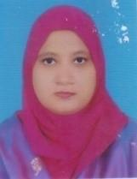 | DR. SHARMIN RABEYA  F/Name: Md. Shab Uddin  M/Name: Diluara Begum  BM & DC Reg. No: 42316  NID: 1696654357489  Cell: 01671945410  Address: House No: 25, Muktar Bari Road, Auchpara, Tongi, Gazipur.  Blood Group: O+
292 | Voter No  LM-2000288 | DR. MD. SULTAN MAHMUD  F/Name: Md. Shah Alam  M/Name: Salina Begum  BM & DC Reg. No: 70140  NID:  Cell: 01982620270  Address: H.NO: 51, W.No:36, Kamarjury, National University, Gazipur.  Blood Group: O+
293 | Voter No  LM-2000289  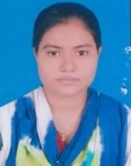 | DR. MAHMODA MALLIK  F/Name: Md. Harun Or Rashid Mallik  M/Name: Asma Hana  BM & DC Reg. No: 80660  NID: 19913393042000024  Cell: 01758048317  Address: H.No. 51, W. No: 36, Kamarjury,, National University, Gazipur.  Blood Group: B+
294 | Voter No  LM-2000290 | DR. TANVIR AHAMED LIPU  F/Name: Alamgir Hossain  M/Name: Latifa Begum  BM & DC Reg. No: 107317  NID: 19923323006000030  Cell: 01752351351  Address: Balochakoli, Gazipur Sadar, Gazipur.  Blood Group: A+
295 | Voter No  LM-2000291 | DR. MD. MOYNUL HOSSAIN  F/Name: Sahadat Hossain Khan  M/Name: Monju Ara Khatun  BM & DC Reg. No: 84704  NID: 19932619676000352  Cell:  Address: Borobari, Gazipur.  Blood Group: A+
296 | Voter No  LM-2000292  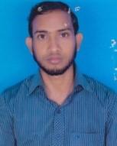 | DR. MD. MAHMUDUL HASAN  F/Name: Md. Mosharauf Hossain  M/Name: Mst. Nurjahan Begum  BM & DC Reg. No: 84716  NID: 19913313266000088  Cell: 01955660660  Address: Gazipura, Gazipur.  Blood Group: A+
297 | Voter No  LM-2000293 | DR. SHAMIM CHOWDHURY  F/Name: Hazi Md. Mohar Ali  M/Name: Amena Begum  BM & DC Reg. No: 80648  NID: 1992331303100516  Cell: 01923284475  Address: Khailkur, National University, Gazipur Sadar, Gazipur.  Blood Group: O+
298 | Voter No  LM-2000294 | DR. ABI UMAR AL FATTAH  F/Name: Taslim Uddin  M/Name: Nurun Nahar  BM & DC Reg. No: 80639  NID:  Cell: 01713173139  Address: Torgash, Gazipur.  Blood Group: O+
299 | Voter No  LM-2000295 | DR. SK SAIFUL ALAM  F/Name: Mohammad Amanul Hossain  M/Name: Shamsun Nahar  BM & DC Reg. No: 35690  NID: 19766125215201302  Cell: 01686075929  Address: 139/C, South Chaya Bithi, Gazipur.  Blood Group: B+
300 | Voter No  LM-2000296  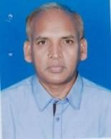 | DR. M.M ABDUL WADUD  F/Name: Late Abdul Ali Molla  M/Name: Late Malumcha Khatun  BM & DC Reg. No: 19028  NID: 2694069158496  Cell: 01772051931  Address: 248/Rokeya Monzil Bide, Gazipur.  Blood Group: B+
301 | Voter No  LM-2000297 | DR. M. TAKMIM RAHMAN  F/Name: Ziaur Rahman  M/Name: Shahana Rahman  BM & DC Reg. No: 65921  NID: 3323004130150  Cell: 01717052482  Address: A/217 Rathkhola Road, Joydebpur, Gazipur.  Blood Group: O+
302 | Voter No  LM-2000298  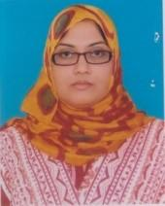 | DR. SAKILA PATUARY  F/Name: Abdus Sattar Patuary  M/Name: Jharna Begum  BM & DC Reg. No: 36416  NID: 3323013336536  Cell:  Address: Auchpara, Tongi, Gazipur.  Blood Group:
303 | Voter No  LM-2000299  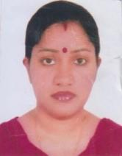 | DR. MOUSUMI DAS  F/Name: Kanti Pada Das  M/Name: Tapati Das  BM & DC Reg. No: 54510  NID: 1592830127126  Cell: 01776482685  Address: 85/A, Kalapatty, Hazipara, Gazipur.  Blood Group: O+
304 | Voter No  LM-2000300 | DR. MD. SHAJEDUL FERDUSH  F/Name: Md. Islami Hossain  M/Name: Shamima Ferdushi  BM & DC Reg. No: 88857  NID: 9135334358  Cell: 01676281002  Address: Vill: Kamarjury, P.O: National University, P.S: Gazipur Sadar, Dist: Gazipur.  Blood Group: A+
305 | Voter No  LM-2000301  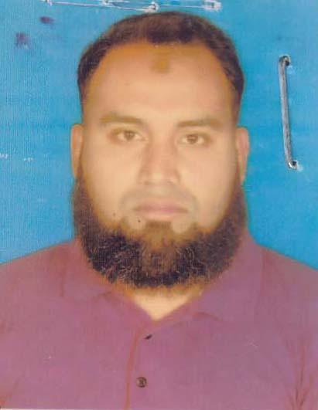 | DR. MD. HOSSAIN AHMED  F/Name: Mr. Md.Altaf Hossain  M/Name: Mrs. Hosneara Begum  BM & DC Reg. No: 55418  NID: 0695 1111 89810  Cell: 01712901701  Address: 39, Uttar Auichpur Hafizuuddin Bepari Road, Gazibari, Tongi, Gazipur  Blood Group:
306 | Voter No  LM-2000302 | DR. FARAH NAZ KHAN  F/Name: Md. Syedul Islam  M/Name: Shahina Islam  BM & DC Reg. No: 61525  NID:  Cell: 01720212620  Address: 500/03, West Vurulia, Post: Duet, Gazipur.  Blood Group: A+
307 | Voter No  LM-2000303  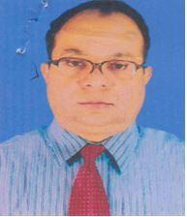 | DR. MD. ASAD HUSSAIN (PROF.)  F/Name: Late. Sohir Uddin Ahmed  M/Name: Late. Aminurnessa Ahmed  BM & DC Reg. No: 21919  NID:  Cell: 01819252525  Address: Prof & Head, Anatomy, Dmc Dhaka Medical College, Dhaka.  Blood Group: n_a
308 | Voter No  LM-2000304  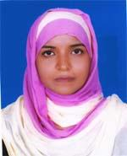 | DR. KAOSARY KHAN KAKON  F/Name: Md. Abul Kashem Khan  M/Name: Rokhsana Khan  BM & DC Reg. No: 45867  NID: 2696406695334  Cell: 01754989938  Address: a  Blood Group: O-
309 | Voter No  LM-2000305 | DR. FEROZA BEGUM  F/Name: Md. Atuar Rahman  M/Name: Mrs. Rezia Rahman  BM & DC Reg. No: 33908  NID:  Cell:  Address: Vill. Shantibag(Shimultali), H/no-457/2, P.O: Chatar, P.s: Joydebpur, Dist. Gazipur  Blood Group: O+
310 | Voter No  LM-2000306  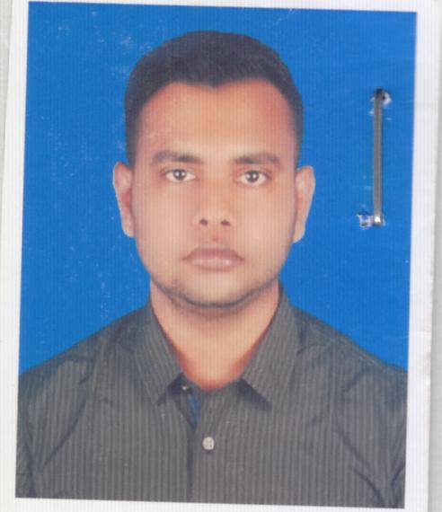 | DR. NUR-A-ALAM SHOVON  F/Name: Md. Golam Idrish  M/Name: Nurun Nahar  BM & DC Reg. No: 89818  NID: 5516521936  Cell: 01674290352  Address: House 34/1, Road: Kuril, Joarsaihara, Khilkhet TSO-1229m Badda, Dhaka  Blood Group: A+
311 | Voter No  LM-2000307  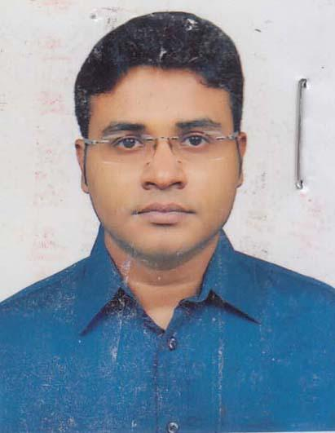 | DR. RASHEDUZZAMAN  F/Name: Shahiduzzaman  M/Name: Rabeya Parvin Banu  BM & DC Reg. No: 84712  NID: 7751867404  Cell: 01834945876  Address: House: 30, Road: 3(B), Sector: 09,Uttara, Dhaka, P.O: 1230, Dhaka.  Blood Group: O+

